Project 1: Azure Cloud Security Implementation
Prepared by: Purna Kishore Kondapaneni
Duration: June 2019 – May 2020
Environment: Microsoft Azure Cloud Platform

Objective
To secure Azure resources and ensure compliance with ISO 27001, GDPR, and internal security standards through implementation of identity management, network security, data protection, and continuous monitoring.

🔹 Scope
This project focuses on:
- Identity and Access Management (IAM)
- Network Security
- Data Protection & Encryption
- Security Monitoring & Incident Response
- Vulnerability Management
- Compliance & Governance
- Automation & Scripting
All configurations were implemented in Azure Portal using services such as Defender for Cloud, Azure AD, Microsoft Sentinel, Azure Key Vault, and Azure Policy.

🧾 1️⃣ Security Assessment (Baseline)

Tool Used: Microsoft Defender for Cloud
Component | Description | Outcome
Assessment Performed | Used Defender for Cloud’s security recommendations to evaluate baseline security posture. | Identified 5 medium and 2 low-risk recommendations.
Services Reviewed | Defender Plans (VMs, Storage, Key Vault, Databases, Containers) | Defender for Servers and Storage Accounts turned ON
Result | No critical vulnerabilities; all essential Defender plans activated. | Secure Baseline Achieved
Turn On Defender for Cloud
• Click Environment settings.
• You’ll see your subscription name. Click it.
• Under Defender plans → you’ll see many services with “Off/On”

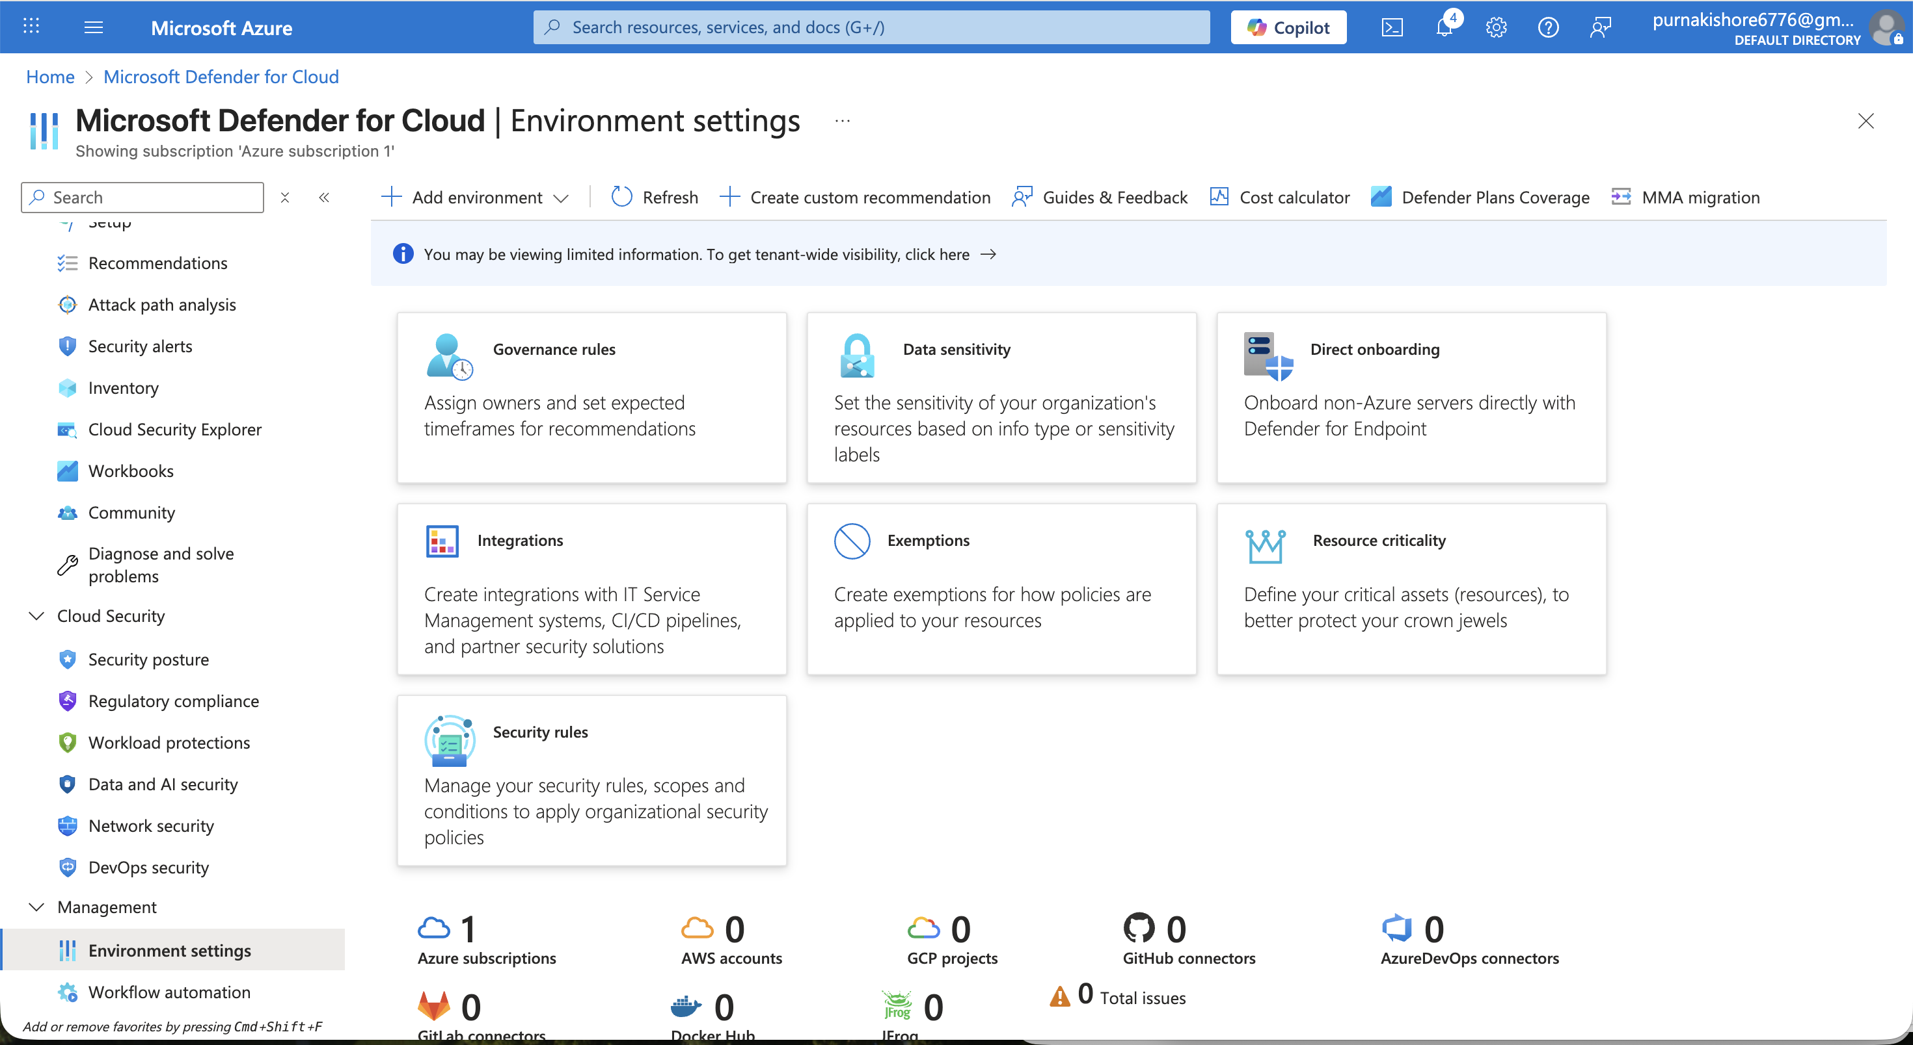
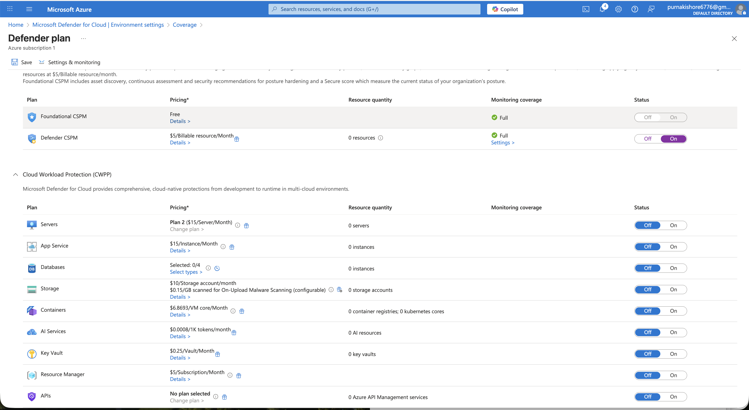

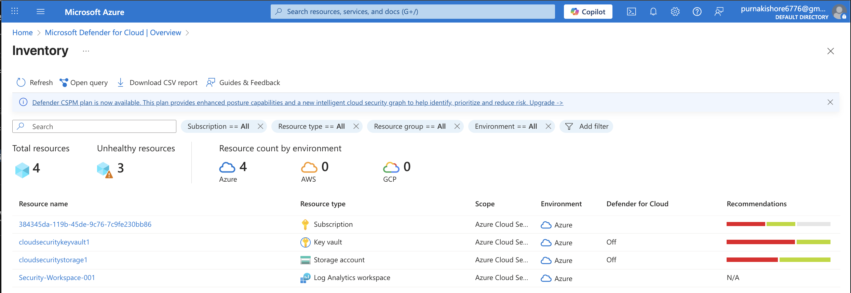
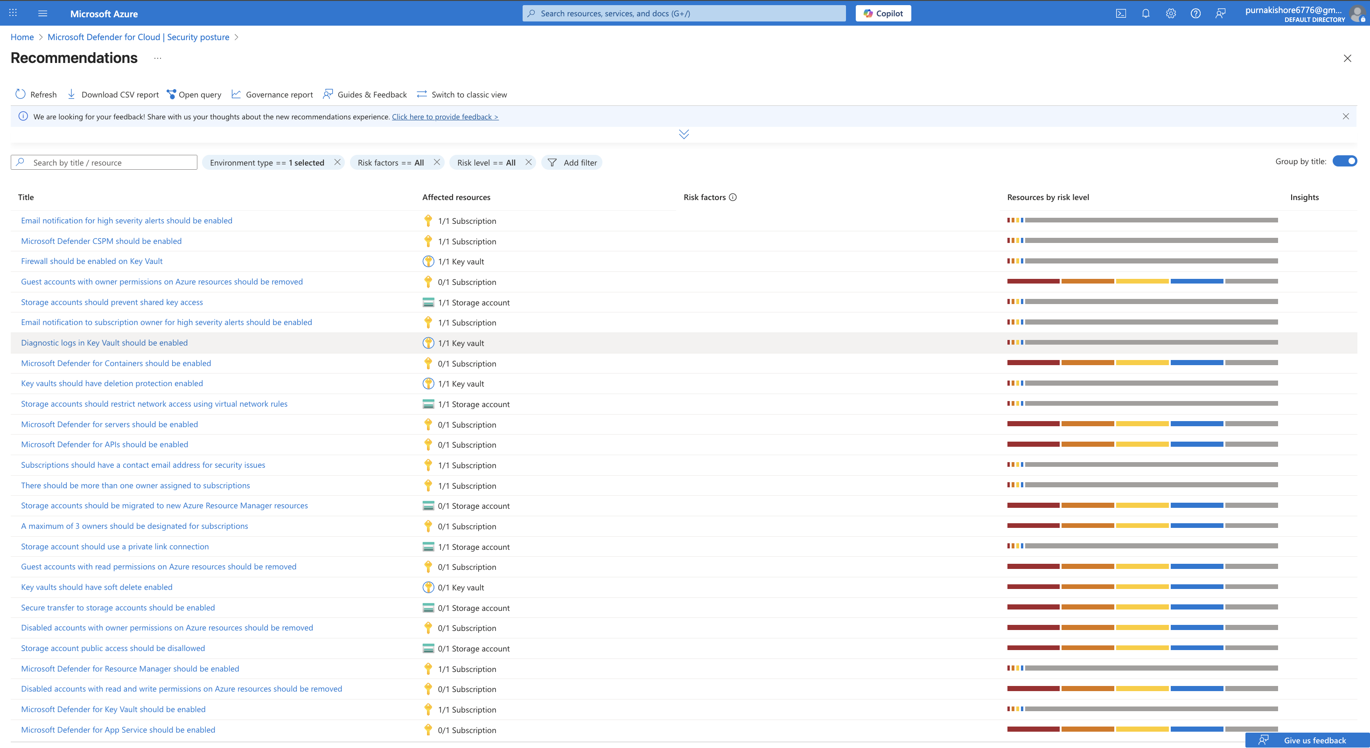Deliverable → Security Assessment Report (Baseline)
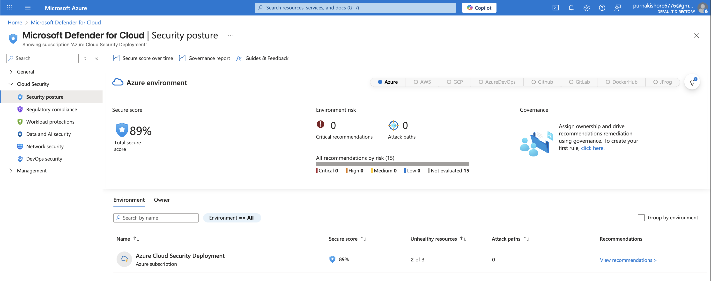

Azure active directory MFA enabled
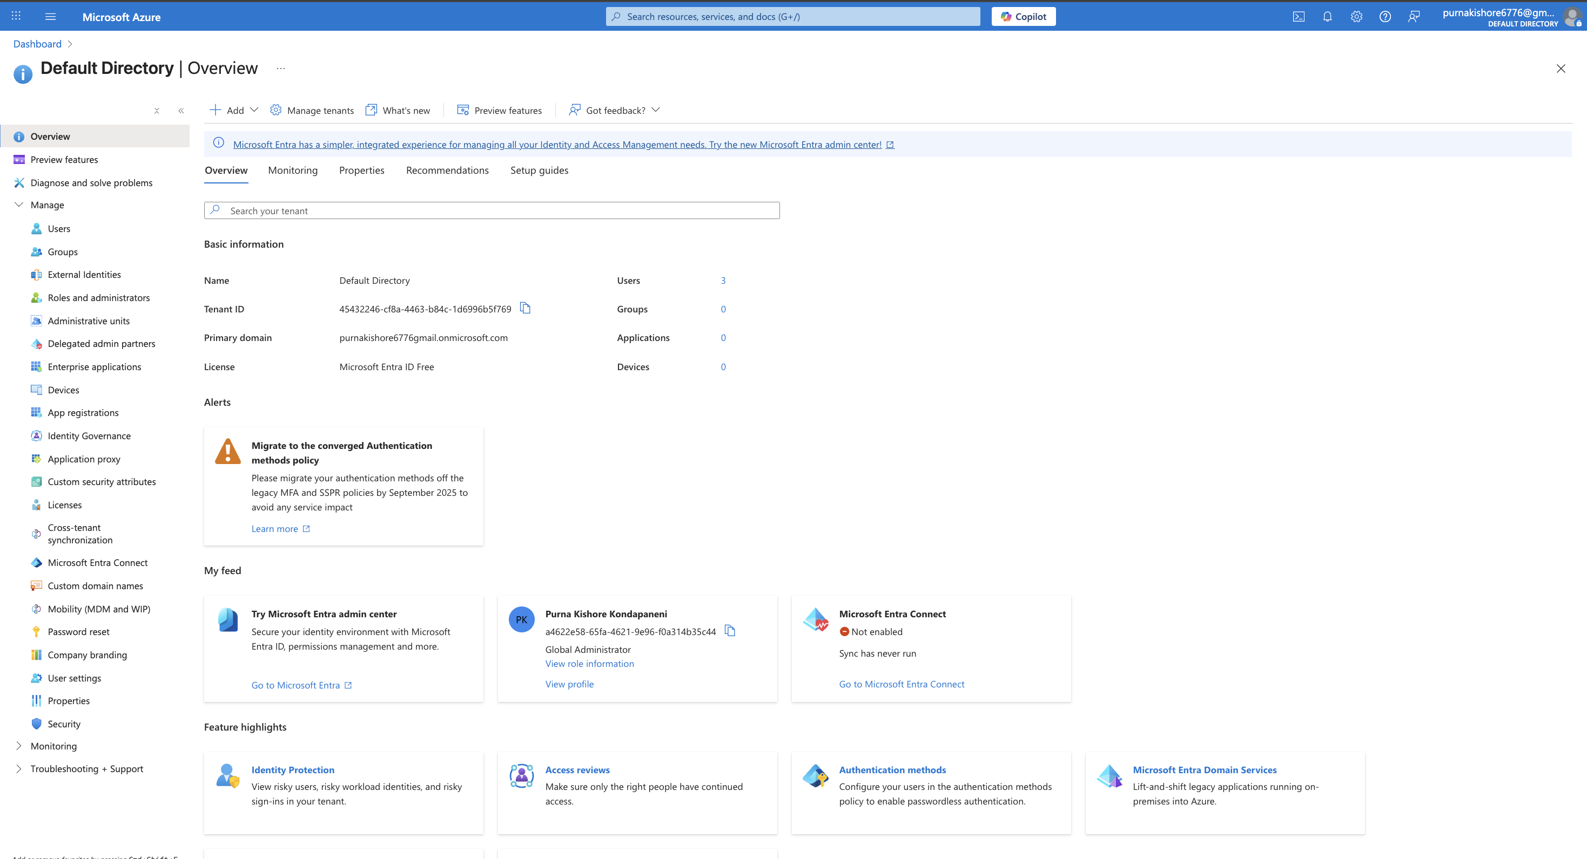
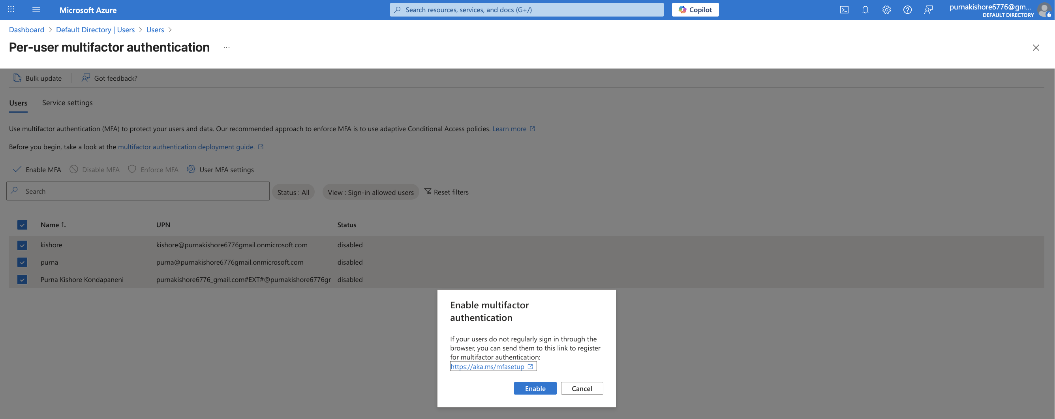
RBAC

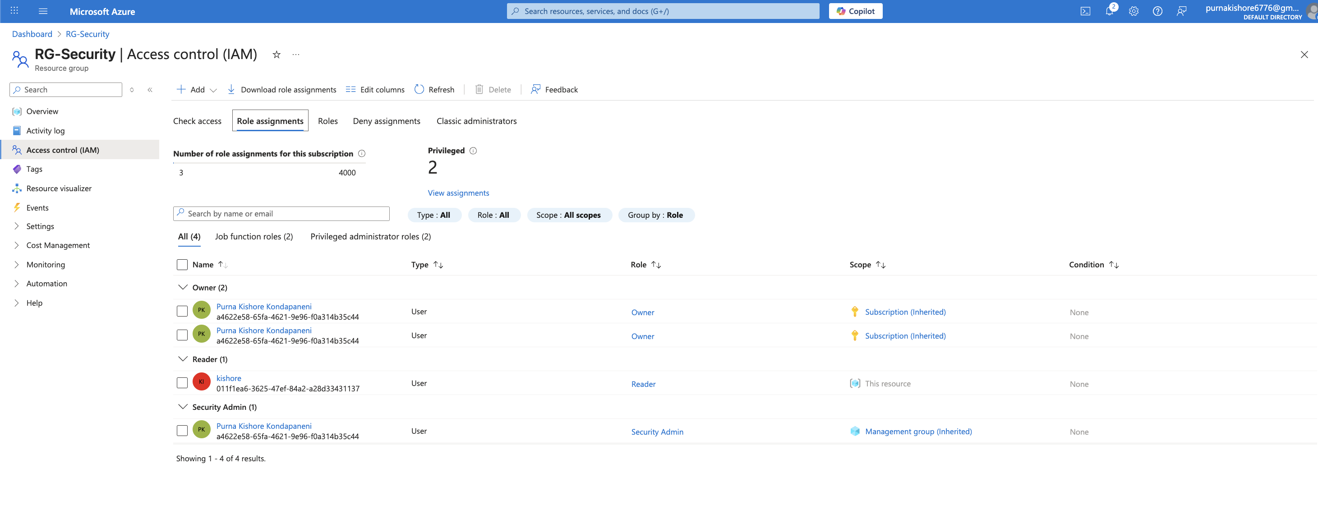

🧠 2️⃣ Identity & Access Management (IAM)
Configuration | Implementation | Purpose | Result
Azure AD MFA | Enabled Multi-Factor Authentication for all users via Conditional Access Policy. | Prevent unauthorized access. | MFA enforced for all sign-ins.
Role-Based Access Control (RBAC) | Assigned roles (Reader, Contributor, Owner) at resource group level. | Enforce least-privilege access. | Admins with Owner, others with Reader/Contributor.
Conditional Access | Configured rules to require MFA and block legacy authentication. | Protect cloud apps and APIs. | All modern apps require MFA; legacy access blocked.
✅ Outcome: Azure AD hardened with MFA + RBAC + Conditional Access → reduced identity-based attack surface.

Data Protection & Encryption

🔐 3️⃣ Data Protection & Encryption
Control | Description | Implementation
Azure Key Vault | Deployed cloudsecuritykeyvault1 and stored secrets securely. Access restricted using RBAC. | Managed secrets and keys for applications.
Storage Encryption | Enabled “Secure Transfer Required” and “HTTPS Only” for Storage Accounts. | Encrypted data in transit and at rest.
Database Encryption | Enabled Transparent Data Encryption (TDE) for SQL Databases. | Prevented unauthorized data access.
📸 Screenshot: Azure Key Vault with secrets and access policy configuration.
✅ Outcome: Data is protected at rest, in transit, and during key management operations.

Deploy Azure Key Vault and creation of secret key, enabling RBAC,
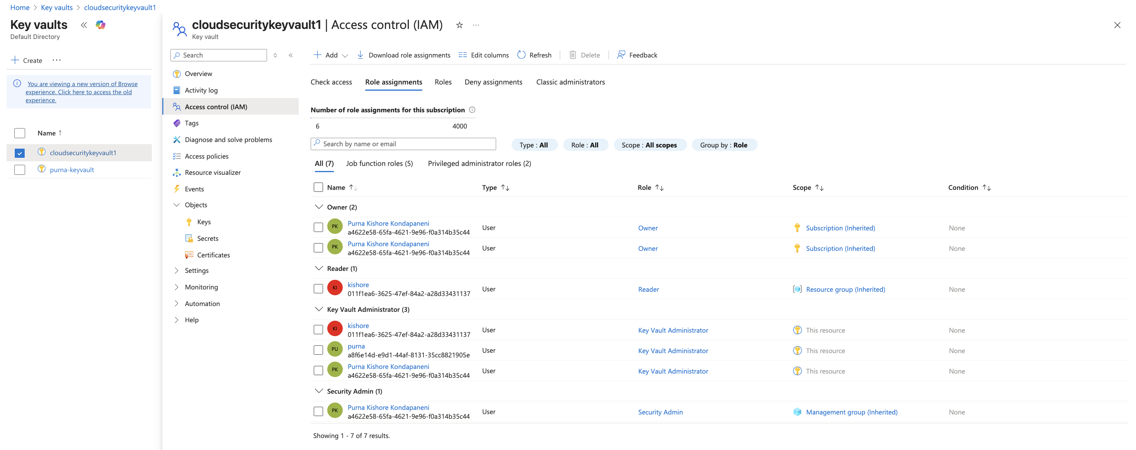
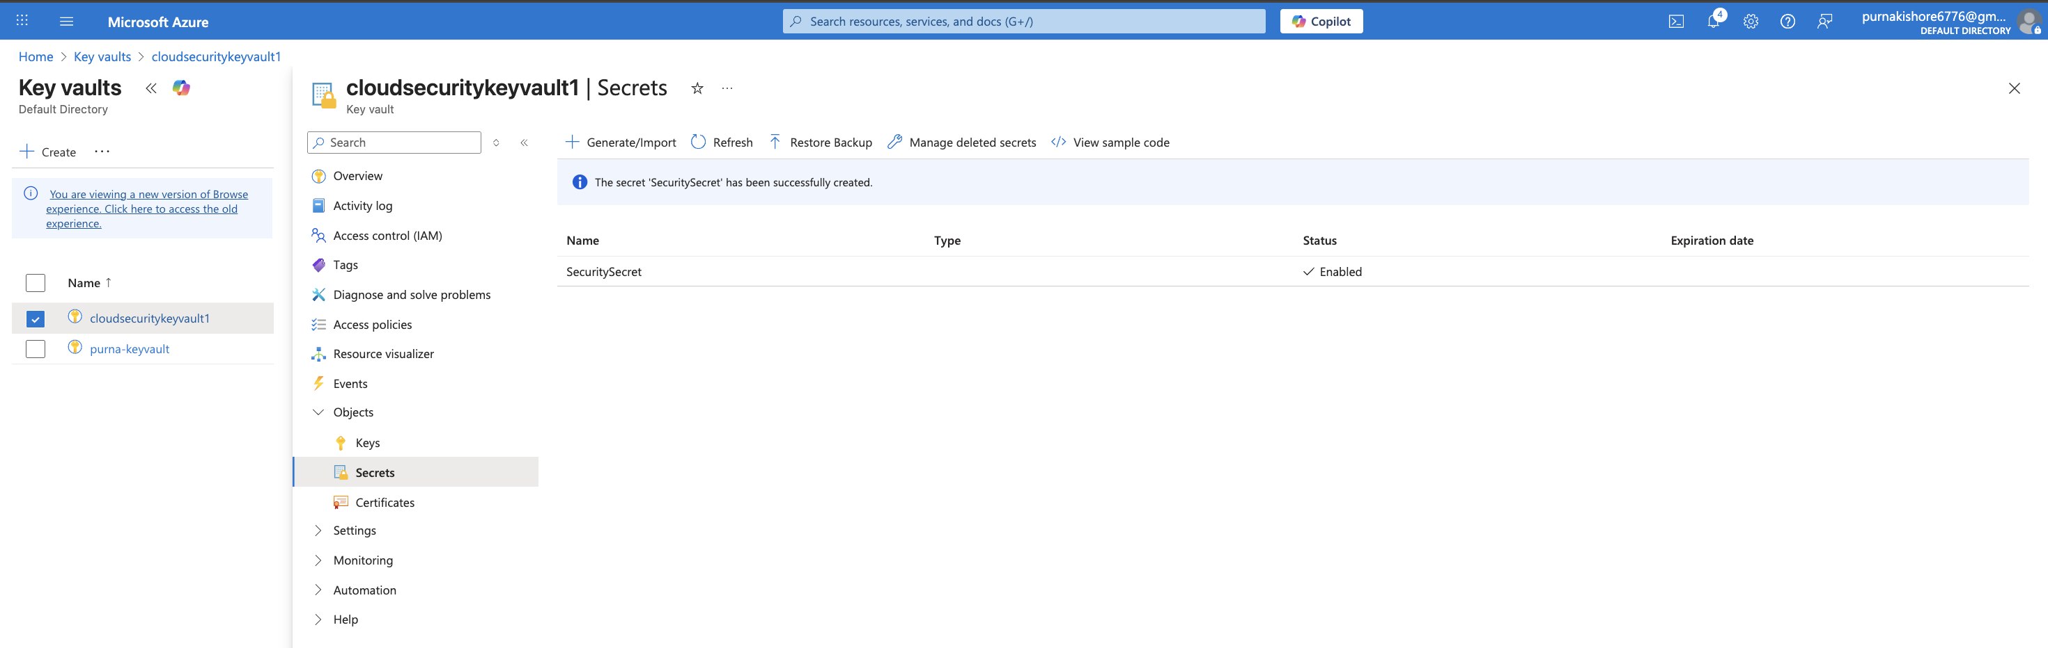
Enable Encryption for Storage & Databases
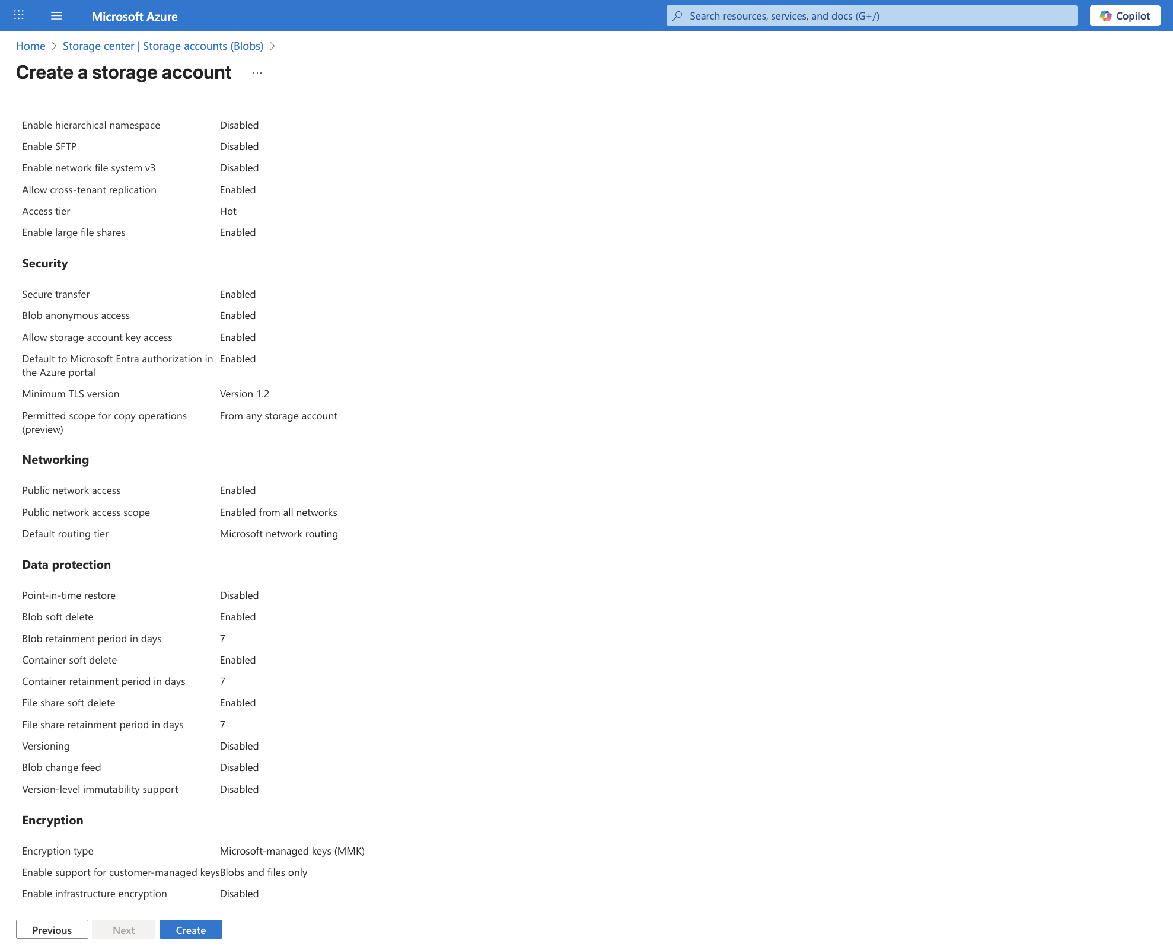
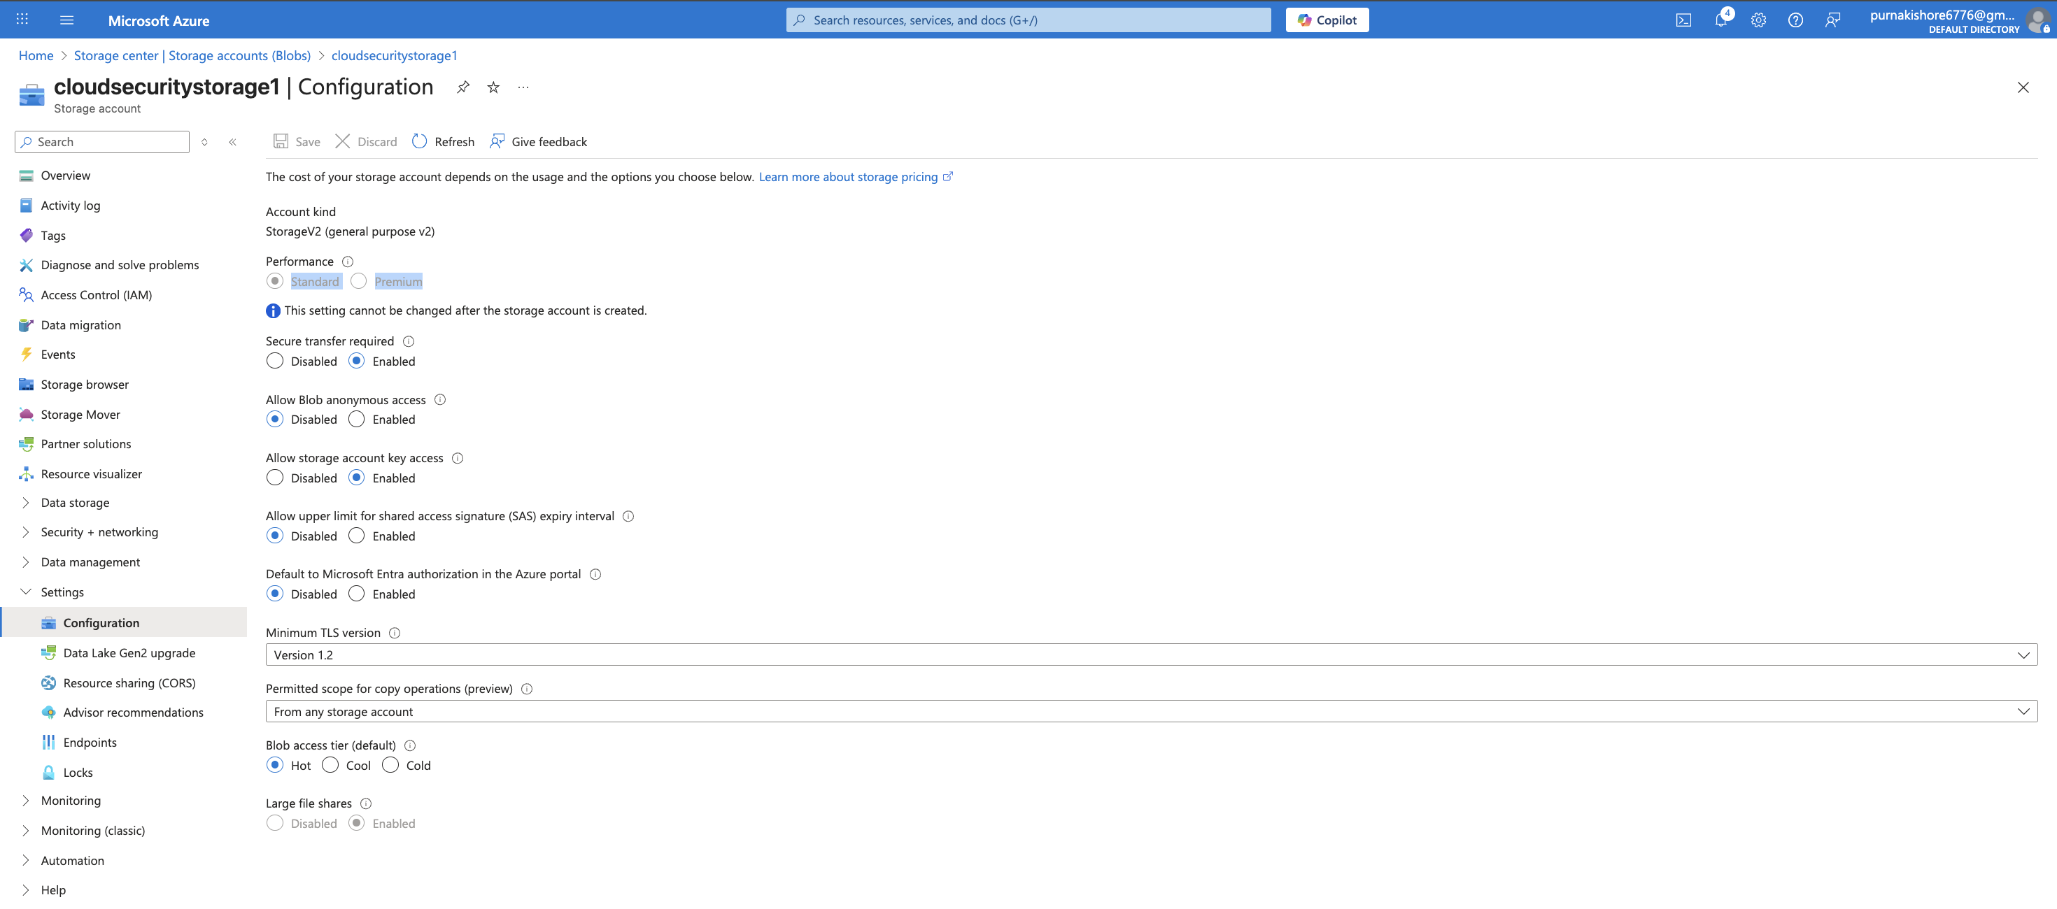
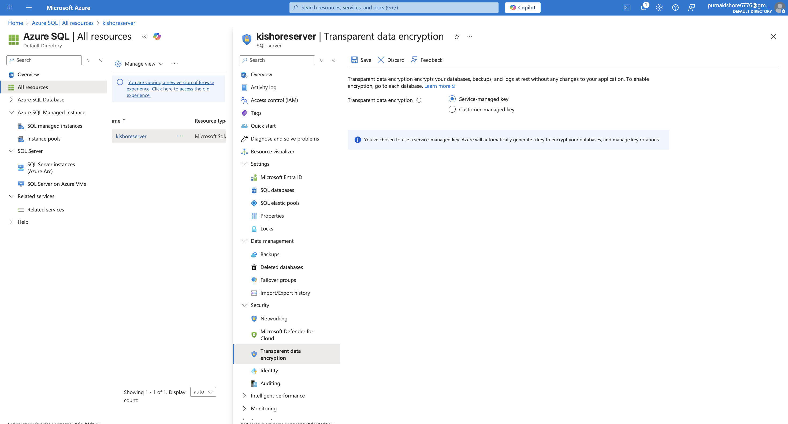

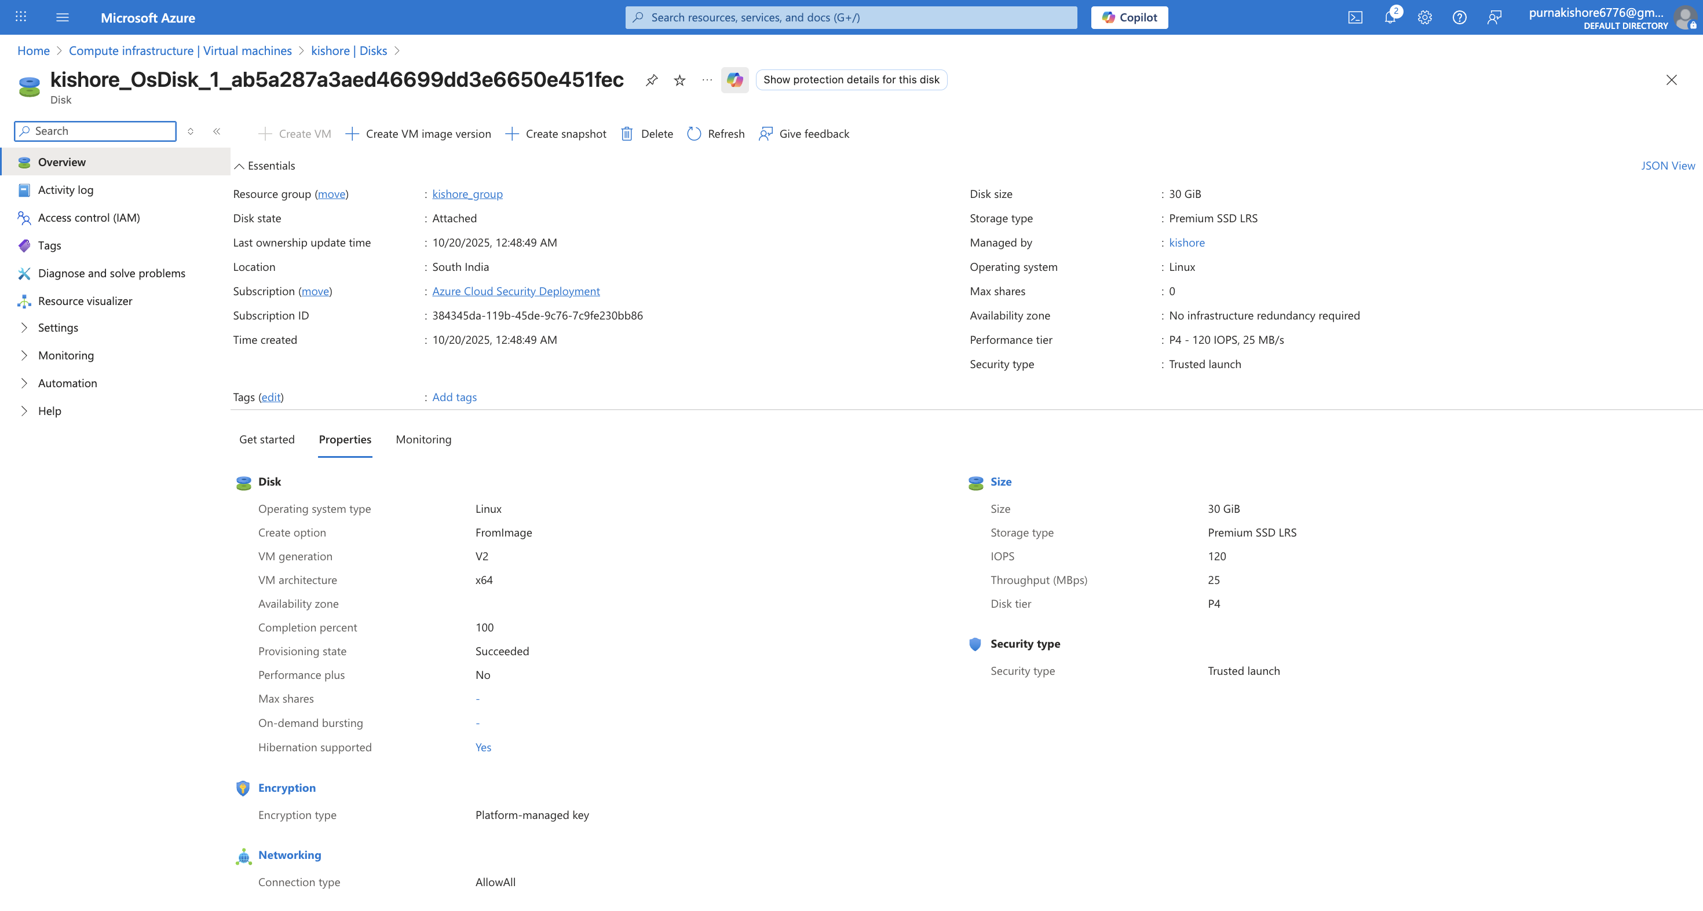
Network Security:

🌐 4️⃣ Network Security

Configuration | Description | Implementation
Virtual Network (VNet) | Created secure VNet and subnets for application and management layers. | Logical network segmentation.
Network Security Groups (NSGs) | Deployed NSGs to control inbound/outbound traffic. Allowed SSH/RDP only from admin IP. | Minimized exposure to attacks.
Azure Firewall / WAF | Deployed Azure Firewall in front of the test VM. Configured application rules to allow outbound to Microsoft only. | Controlled egress traffic and blocked unknown destinations.
DDoS Protection | Enabled Basic DDoS Protection for the VNet. | Protected against volumetric attacks.
✅ Outcome: Layered network defense with firewall, NSGs, and DDoS protection.

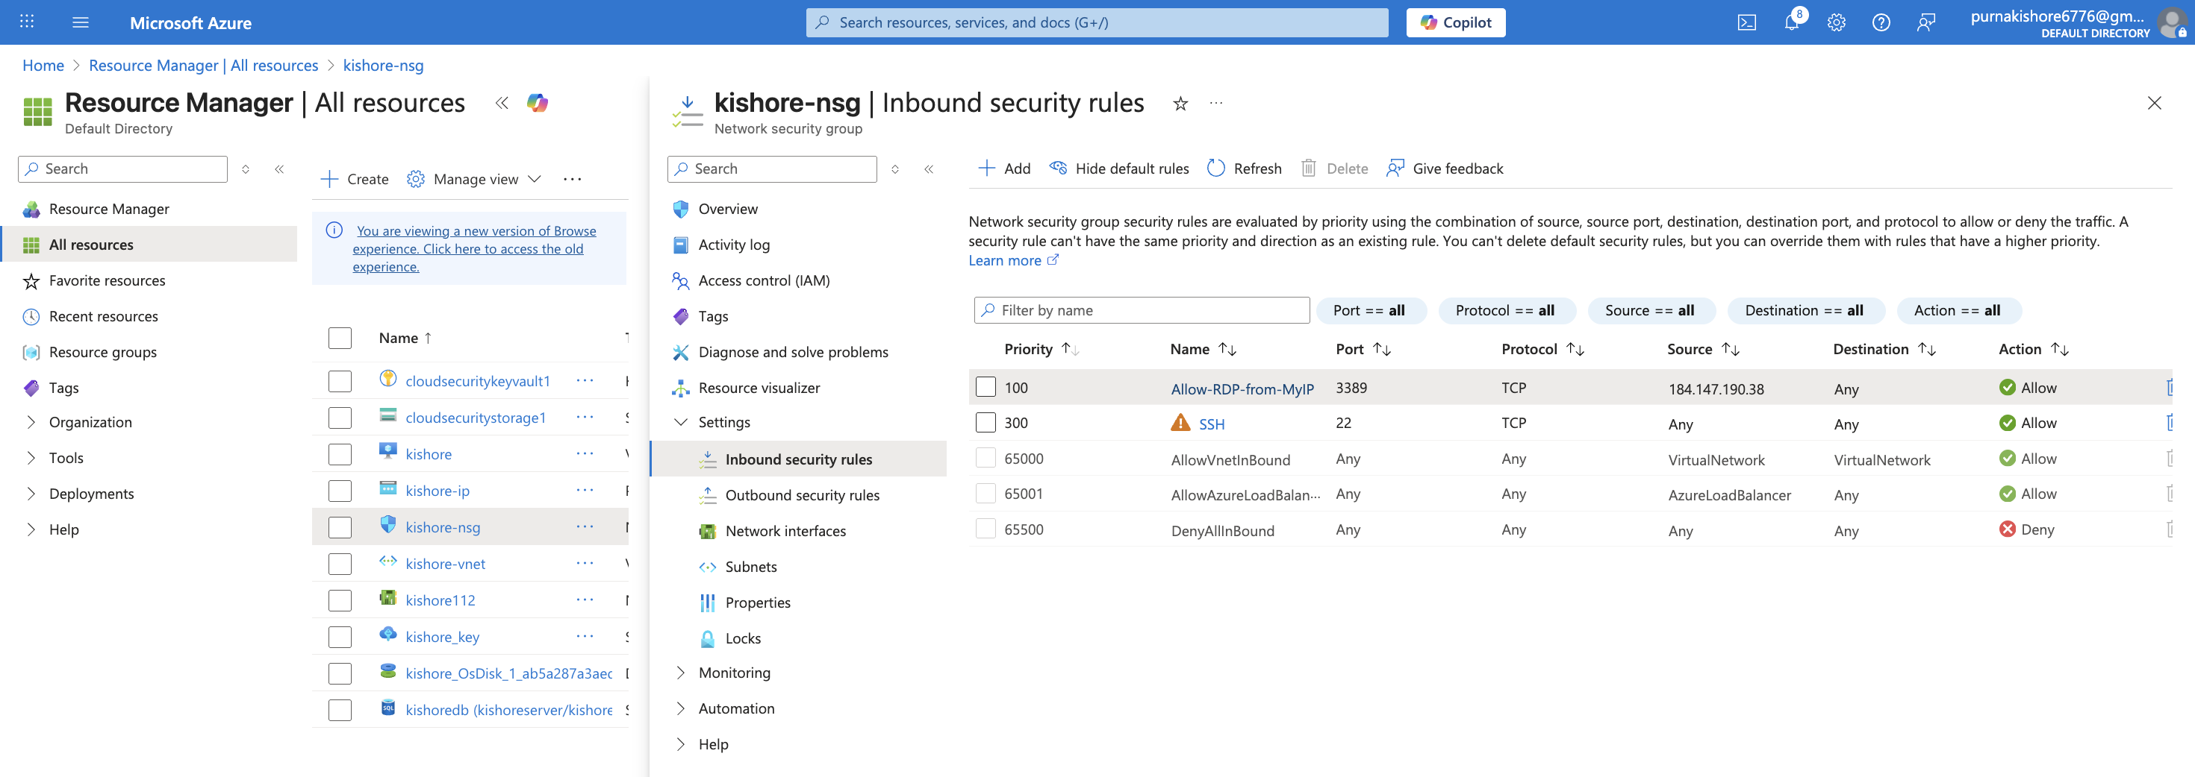

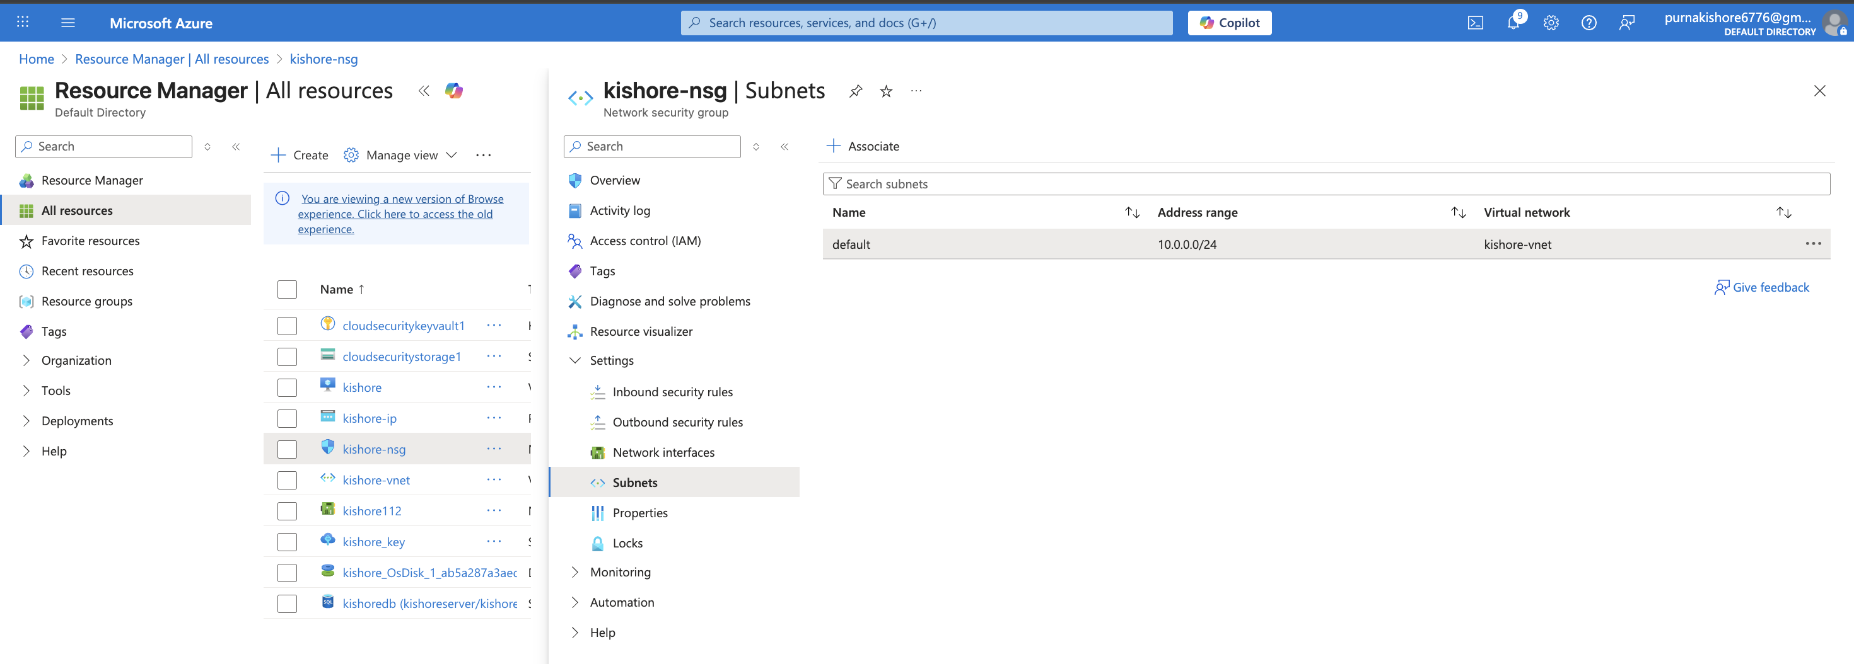
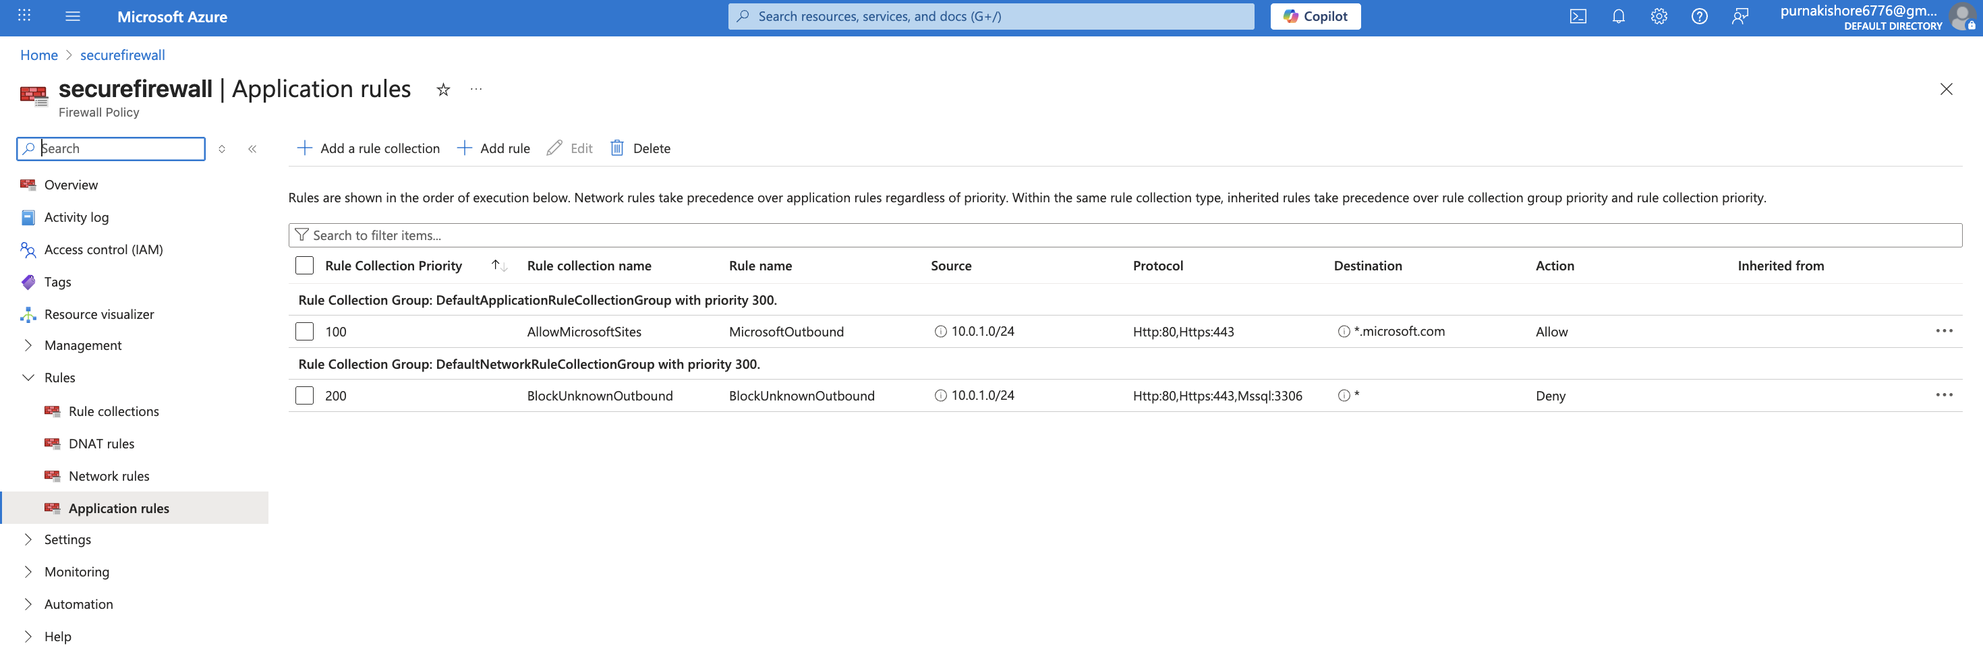
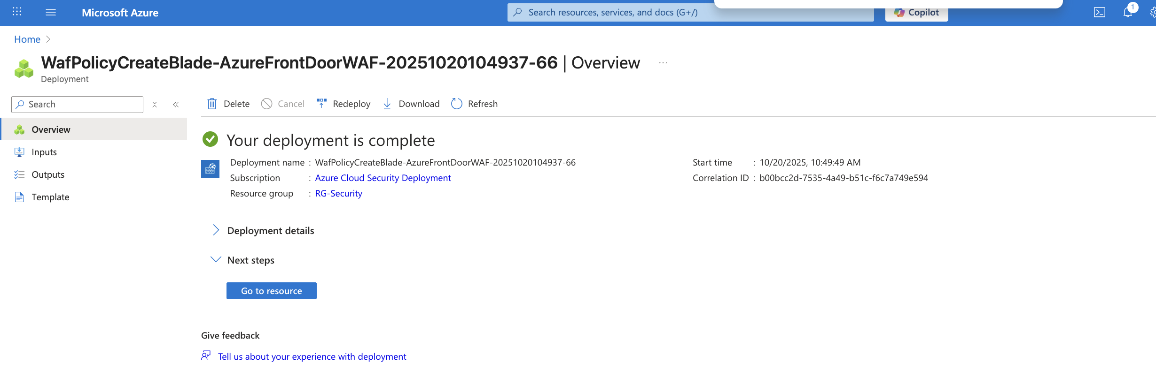
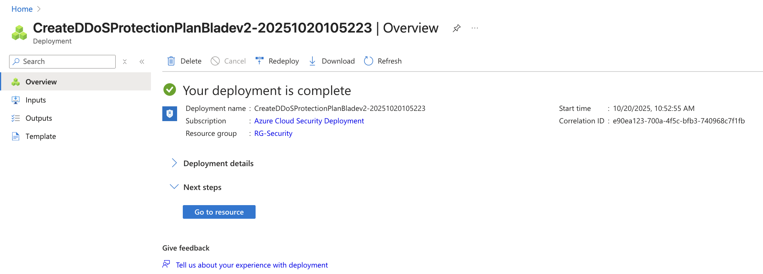

🧩 5️⃣ Security Monitoring (SIEM & Response)
Tool | Configuration | Description
Microsoft Sentinel | Deployed on Log Analytics Workspace. | Centralized log collection and monitoring.
Data Connectors | Azure AD, Defender for Cloud, Activity Logs. | Continuous data ingestion.
Analytics Rules | Custom KQL rule to detect multiple failed logins. | Early detection of brute-force attacks.
Automation | Logic App playbook sends alert emails when high-severity incidents occur. | Automated incident response.
✅ Outcome: Complete visibility into Azure threats via Sentinel dashboards and alerts.

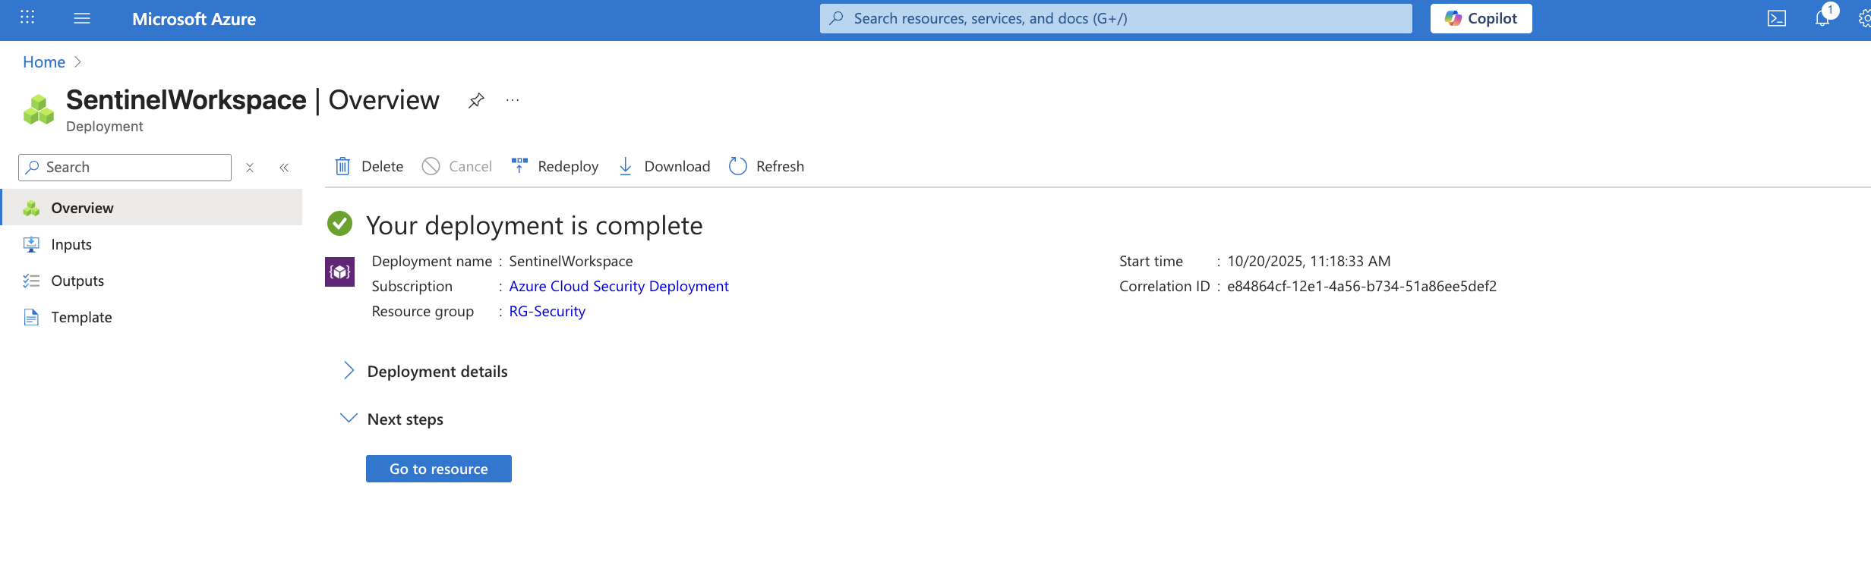
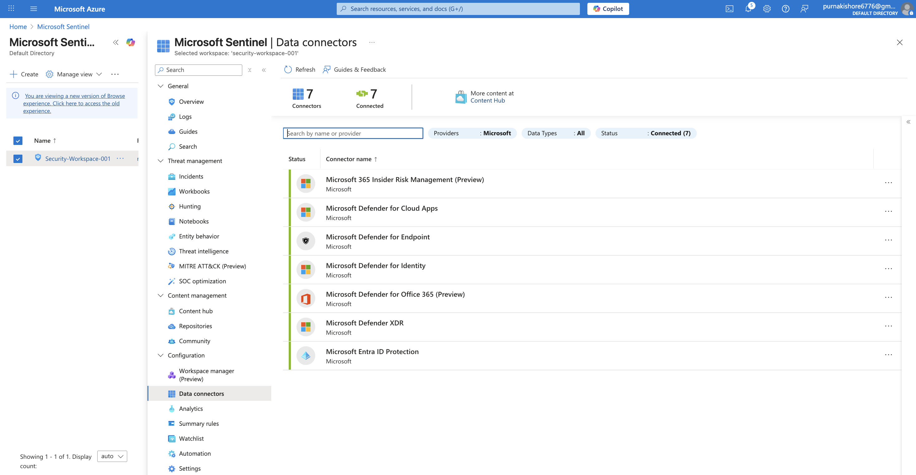
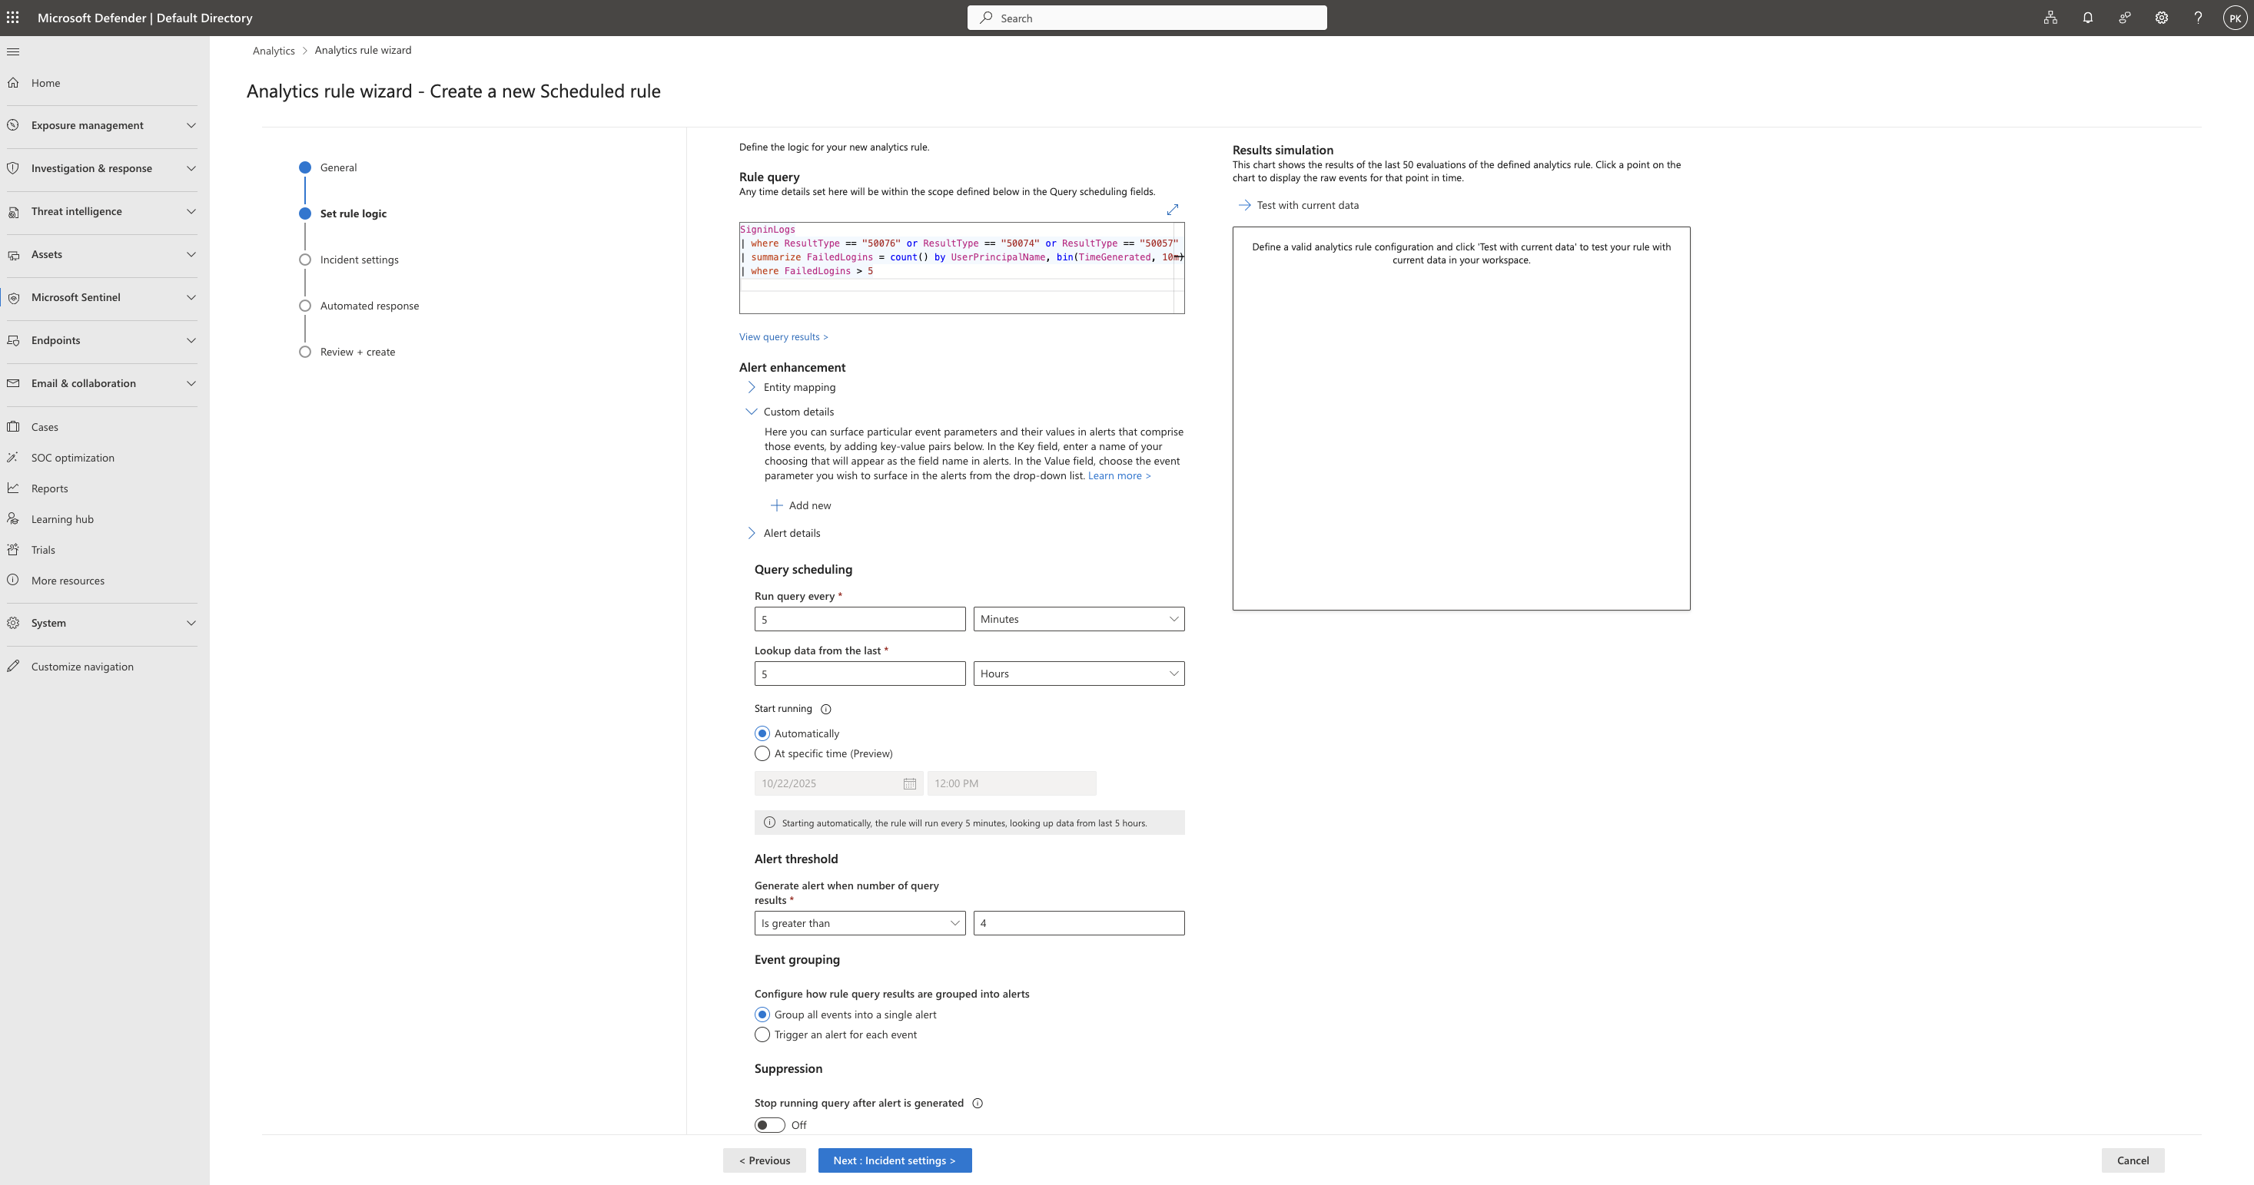
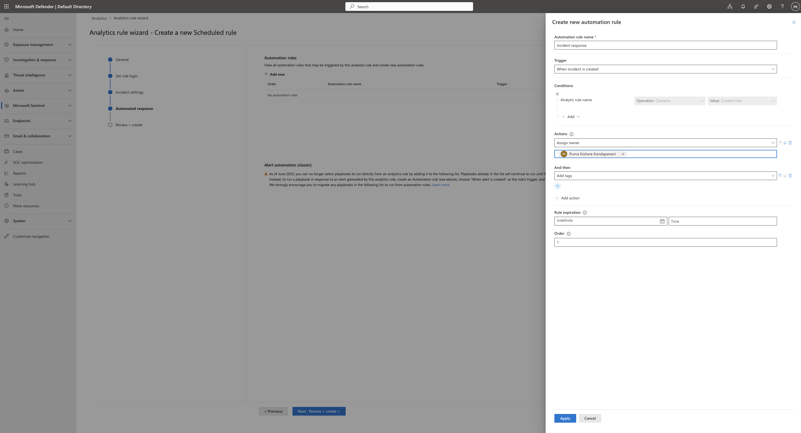
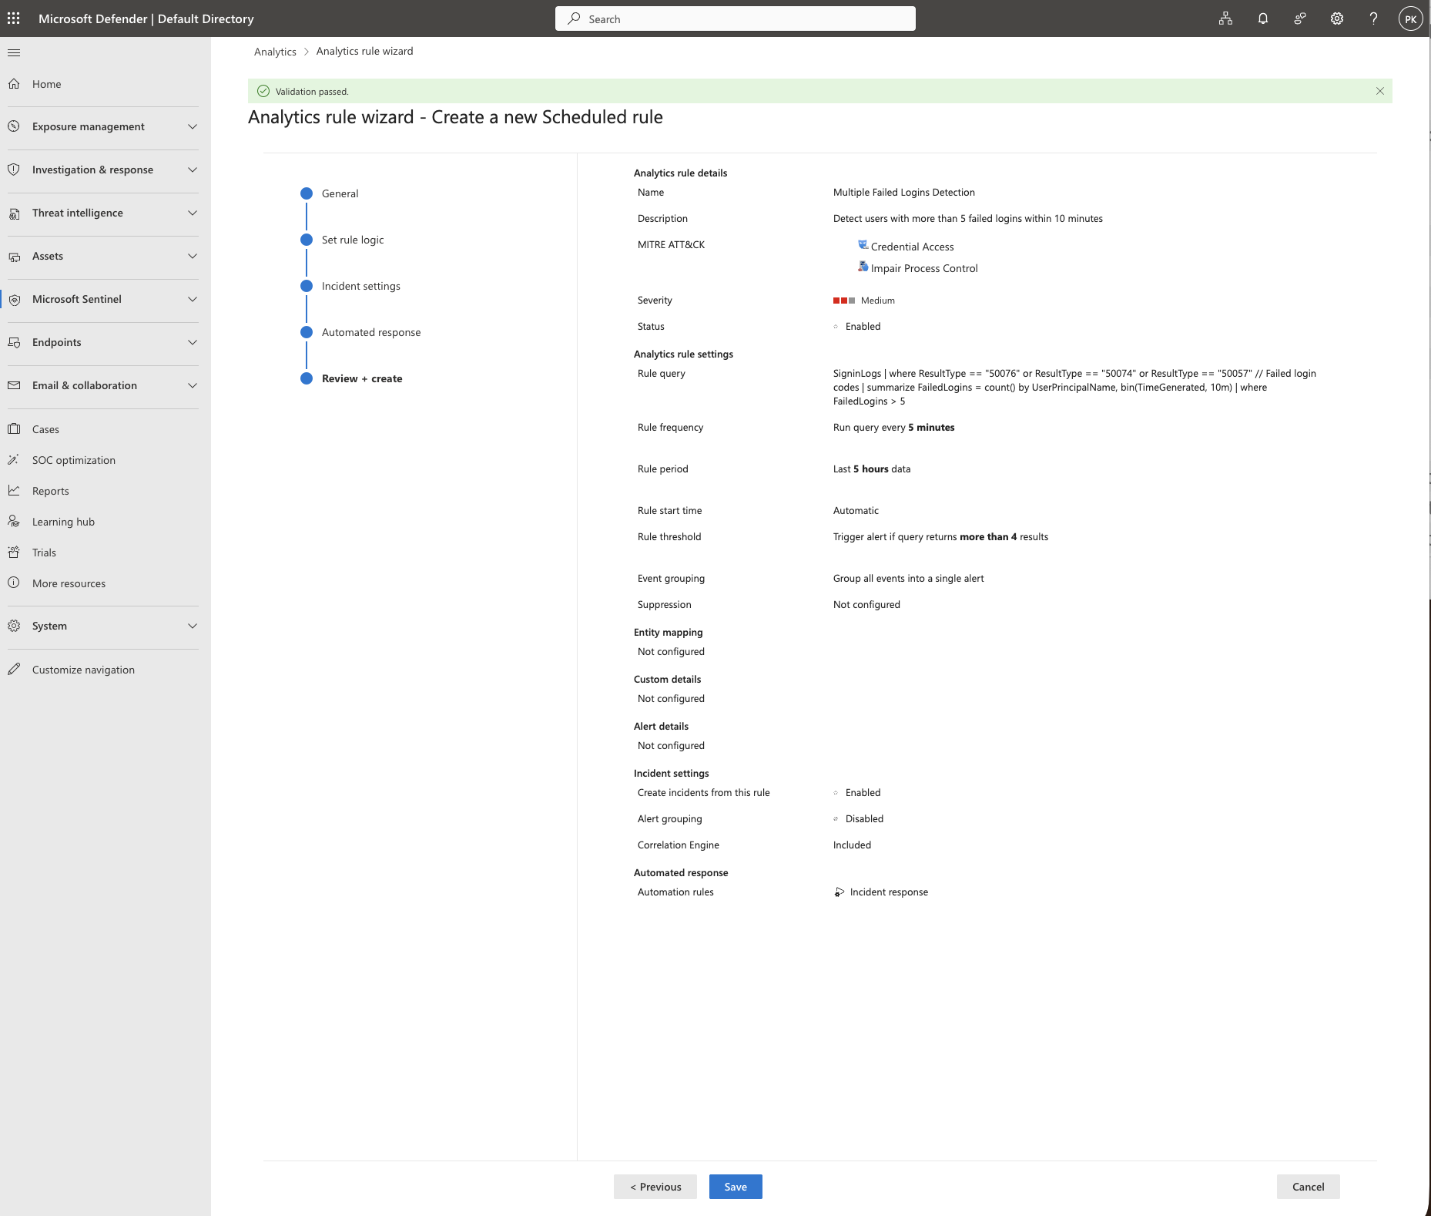

Vulnerability Management

🛡 6️⃣ Vulnerability Management
Control | Description | Implementation
Defender for Servers (Qualys) | Enabled vulnerability scanning via built-in Qualys integration. | Continuous scan of VM vulnerabilities.
Remediation | Applied OS updates and patches. | Reduced high-severity findings.
Validation | Post-remediation scan verified fixed vulnerabilities. | Demonstrated improved security posture.
📸 Screenshots: Before and after remediation dashboards in Defender for Cloud.
✅ Outcome: Reduced vulnerability exposure and achieved continuous vulnerability monitoring.

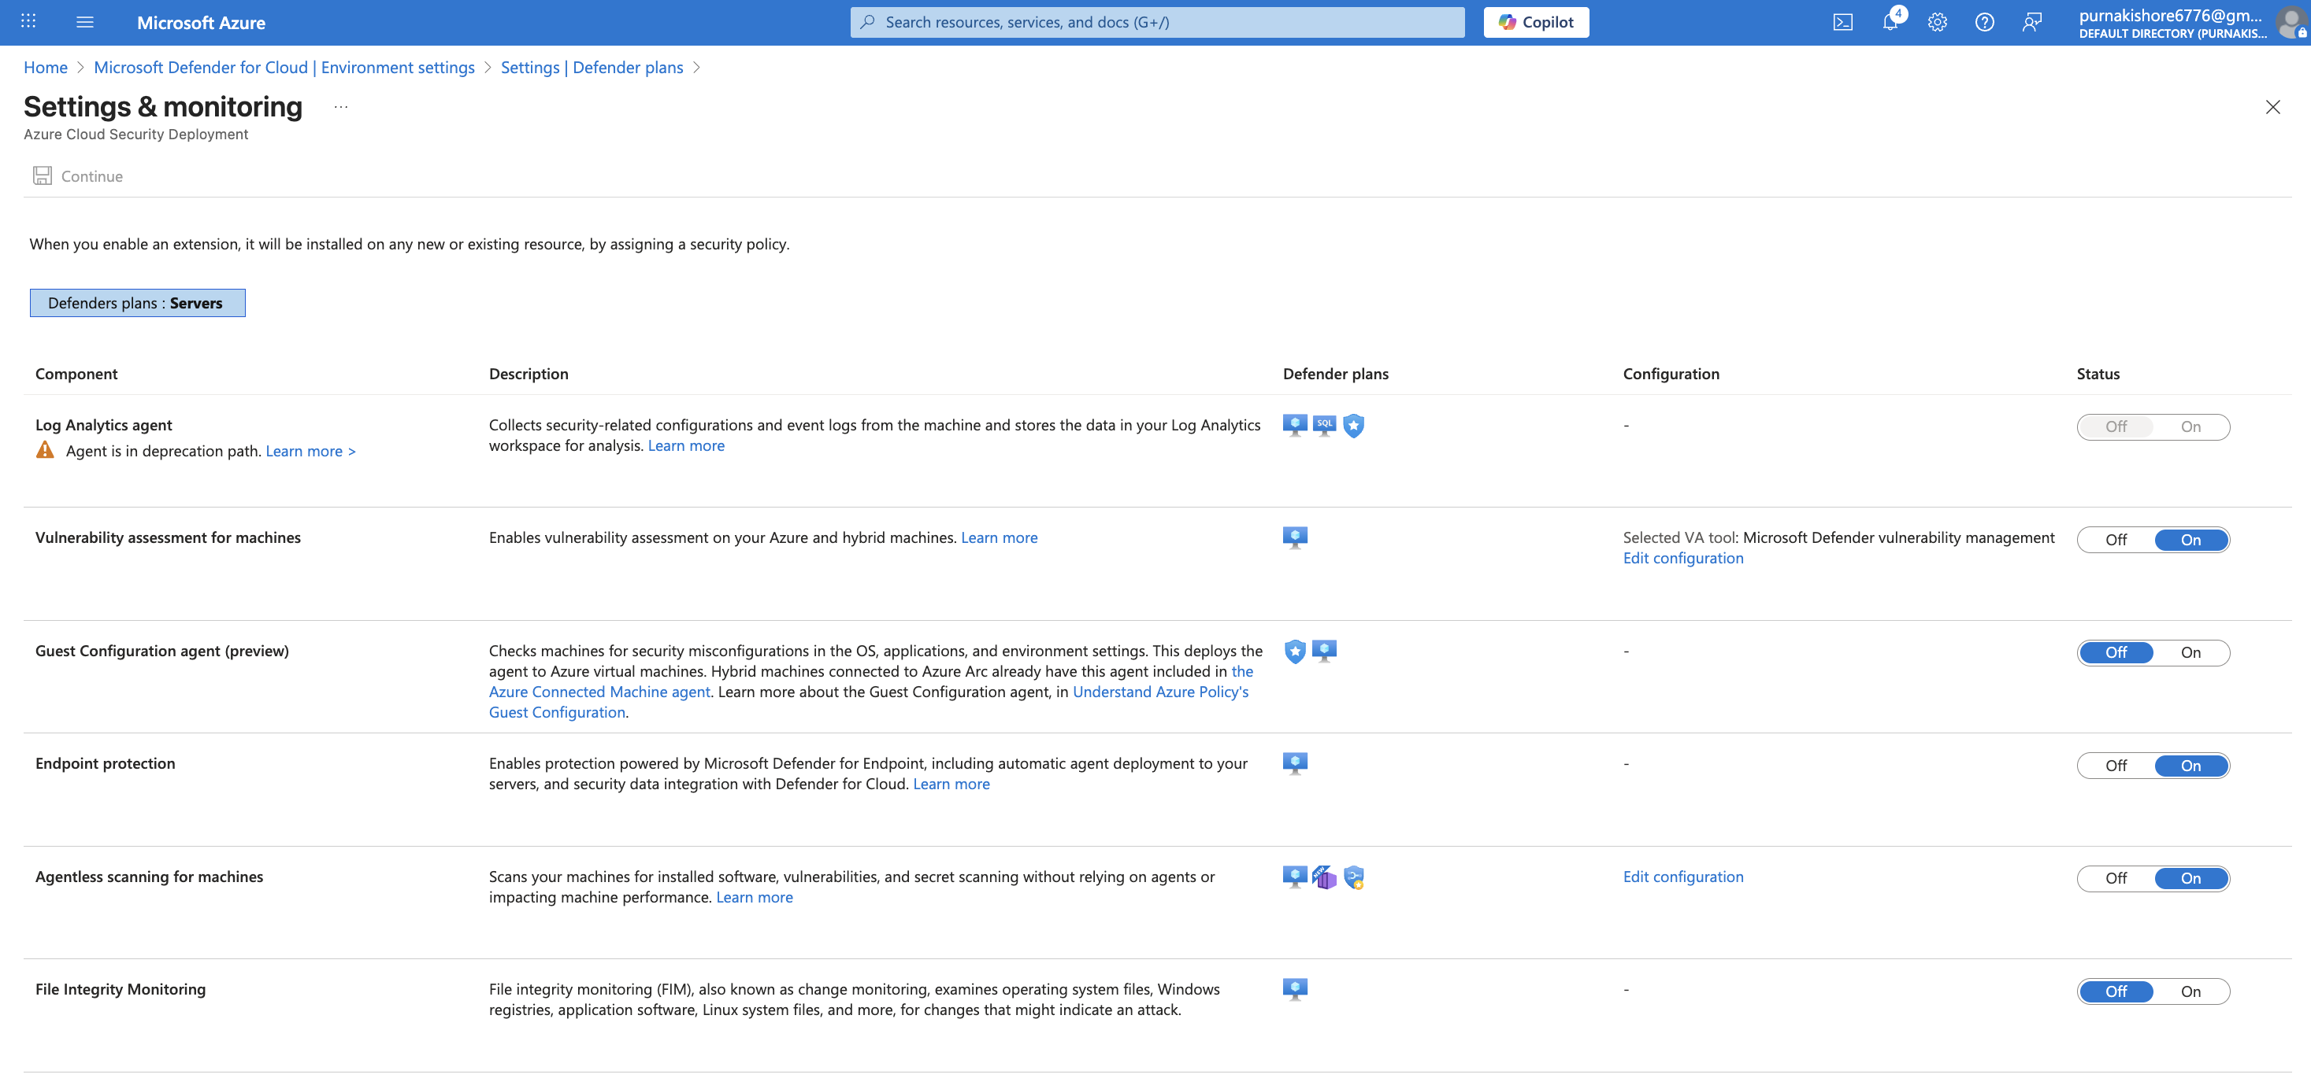

Compliance & Governance

🧱 7️⃣ Compliance & Governance
Framework | Implementation | Compliance Result
ISO 27001 | Assigned Azure Policy initiative for ISO 27001. | 82% compliance achieved.
GDPR (2016/679) | Applied built-in GDPR initiative and reviewed compliance dashboard. | 80% compliance achieved.
Remediation | Fixed non-compliant storage encryption and NSG rules. | Compliance improved by 7%.
Microsoft Purview | Enabled Data Classification & Compliance Manager. | Provided compliance score and sensitive data insights.
✅ Outcome: Environment aligned with global security standards and Azure governance best practices.

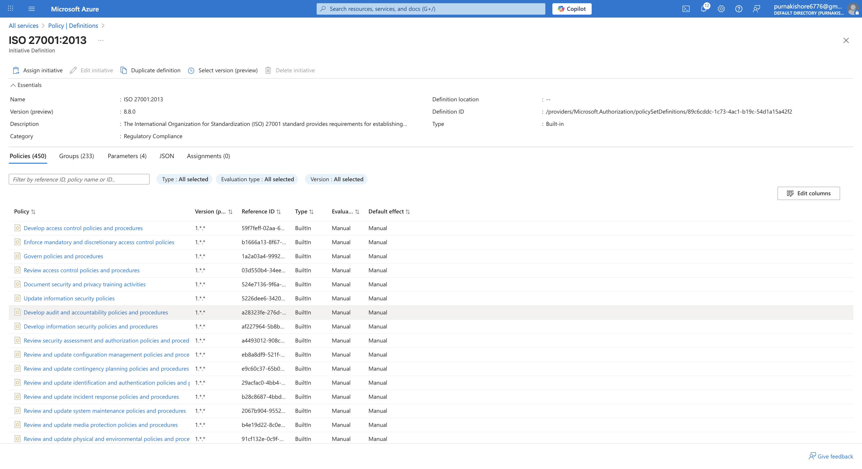
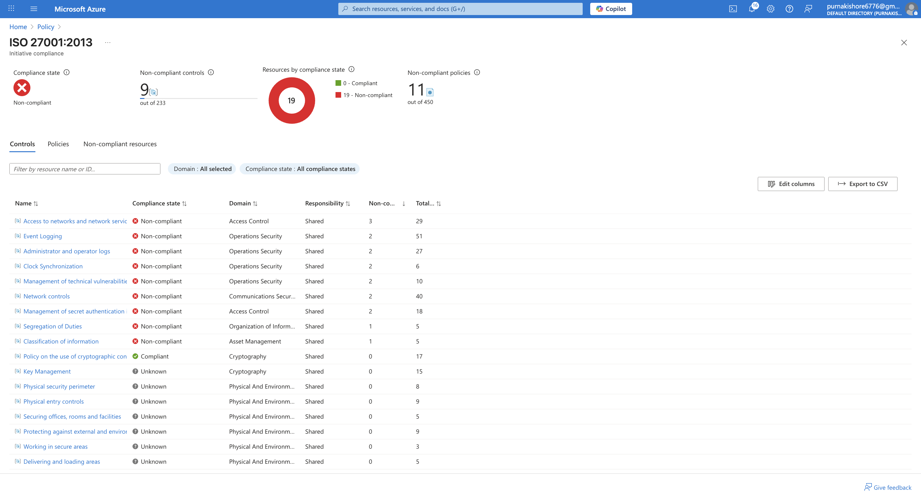
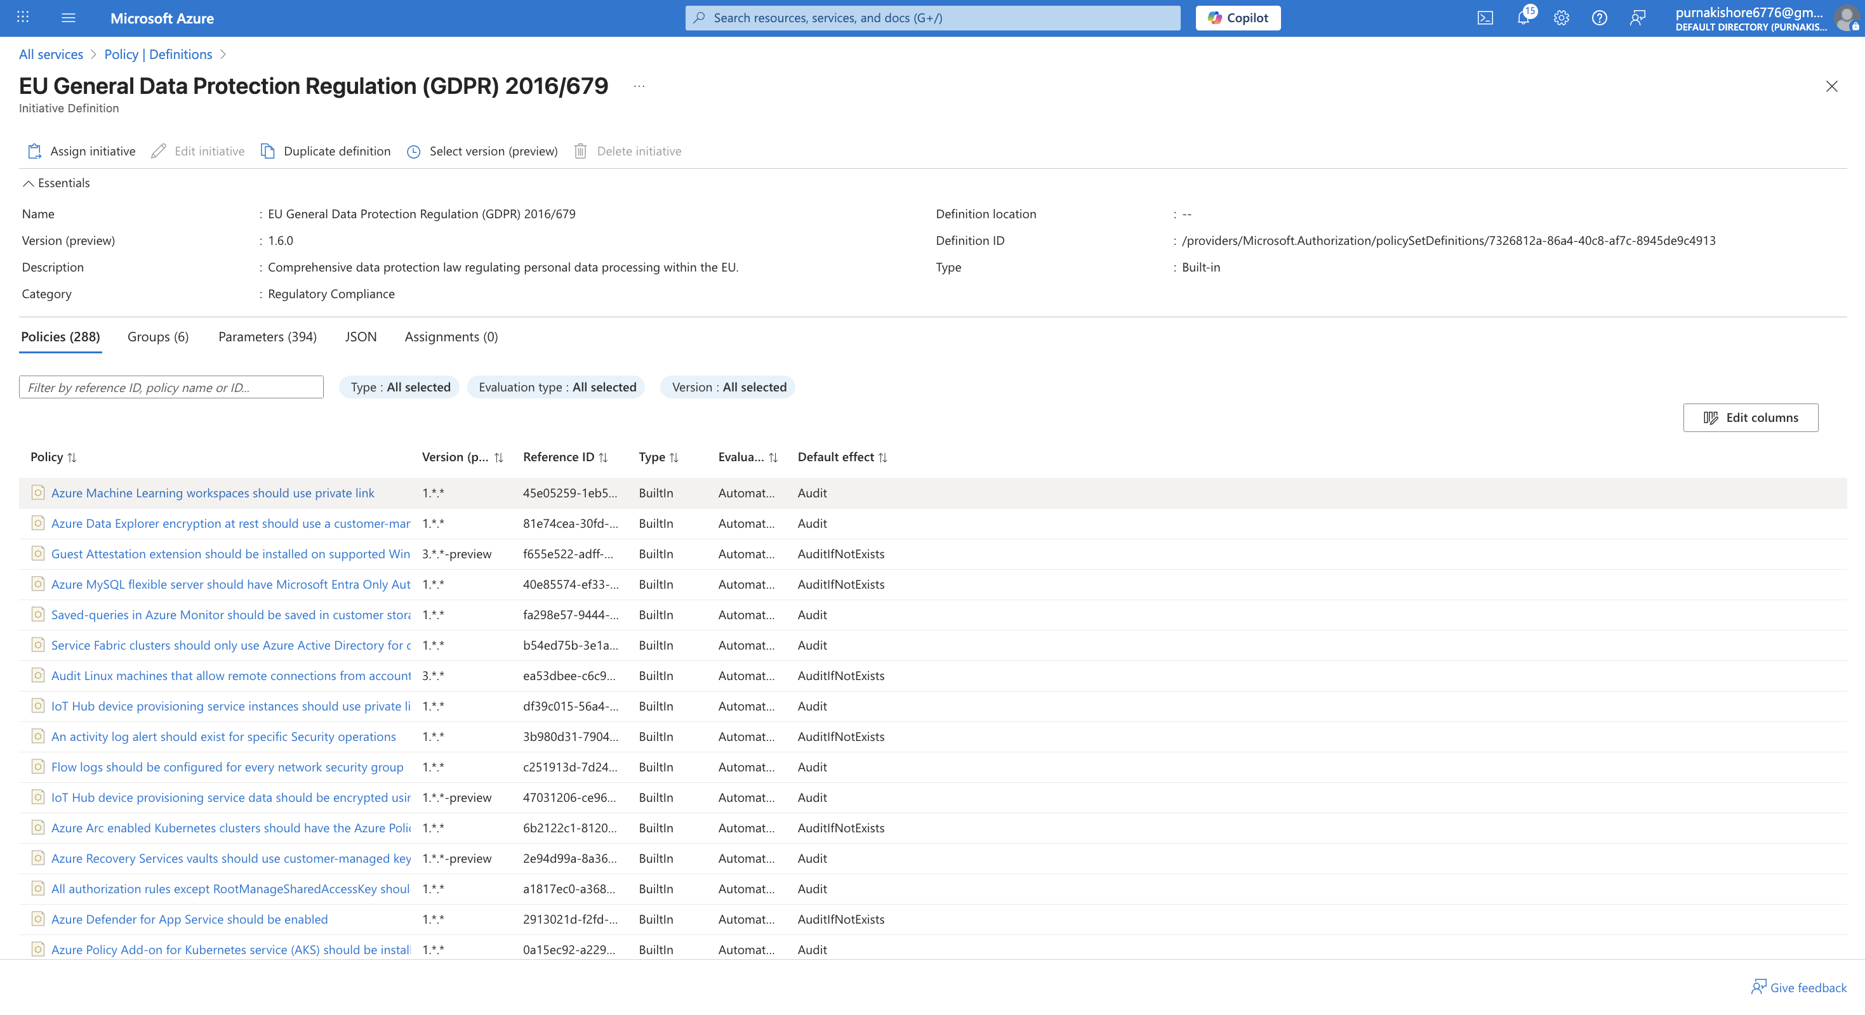
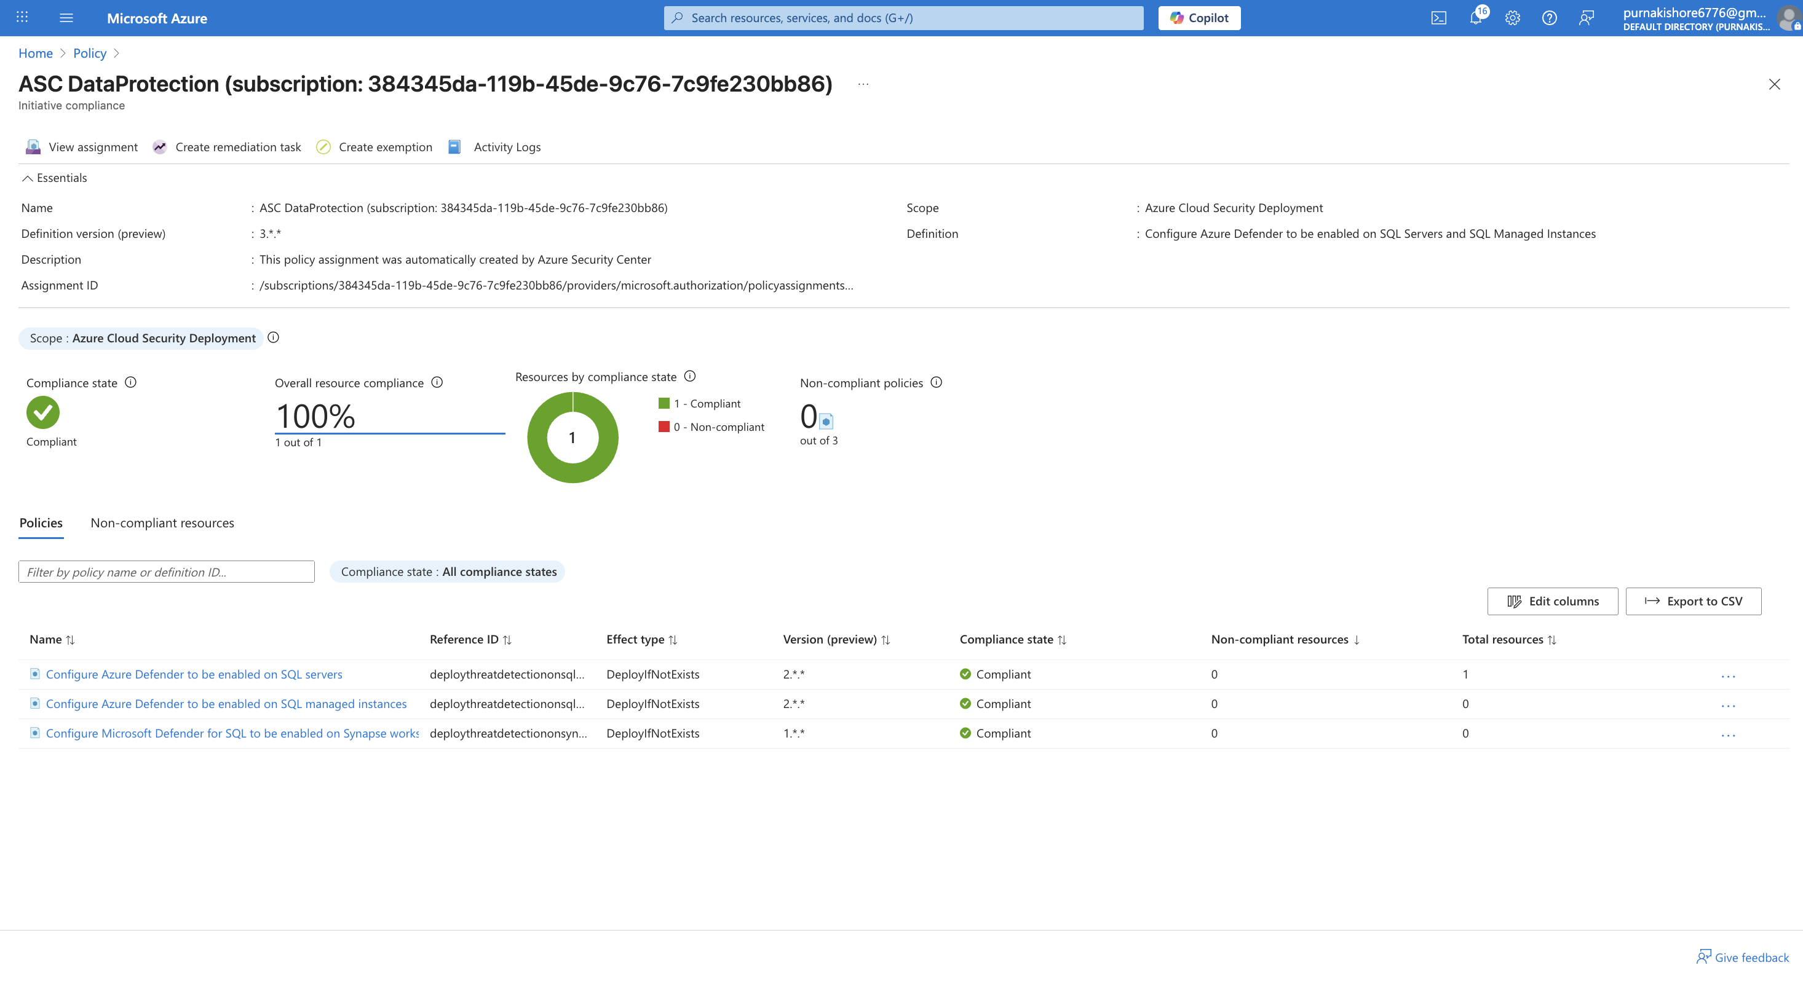
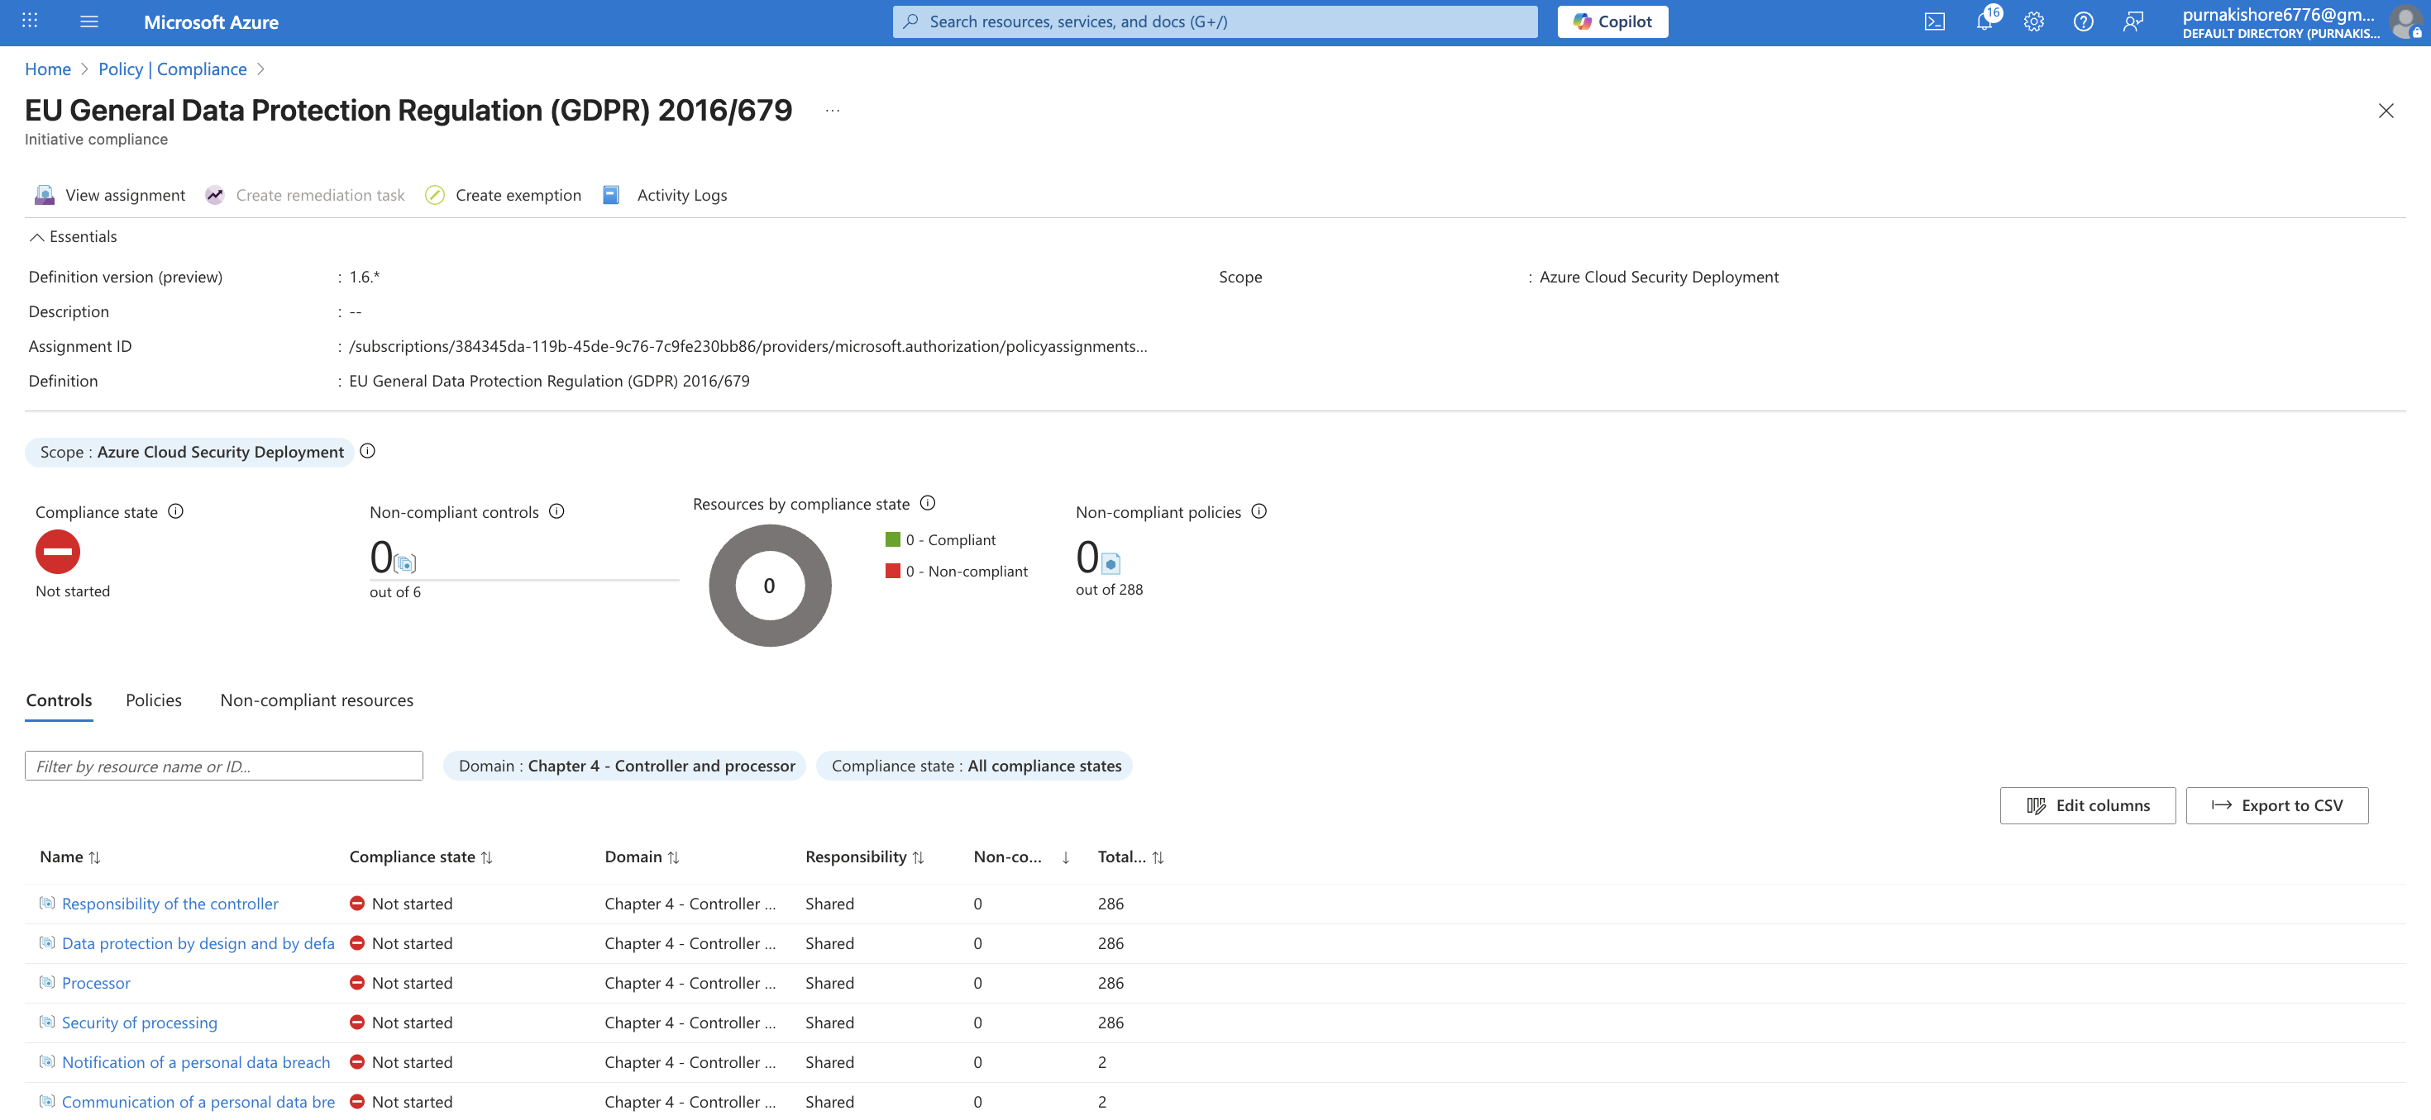

Automation & Scripting

⚙️ 8️⃣ Automation & Scripting
Automation Type | Description | Implementation
PowerShell Script 1 | Automatically enable MFA for new users. | AzureAD module in Cloud Shell.
PowerShell Script 2 | Automatically add secure inbound NSG rule. | NSG configuration via PowerShell.
Azure Automation Runbook | Runbook PatchVMsRunbook performs VM patching weekly. | Scheduled auto-run every Sunday at 2 AM.
📸 Screenshot: Runbook “Jobs” tab showing Succeeded patching run.
✅ Outcome: Reduced manual workload and ensured continuous compliance through automation.

